# Top 10 foods rich in Vitamin B1 (Thiamin)

Thiamine is an essential nutrient, and all the tissues of the body, including the brain, need thiamine to function properly. The body needs thiamine to make adenosine triphosphate (ATP), a molecule that transports energy within cells.

**Vitamin B1 helps the body to:**

Thiamin (vitamin B1) helps the body's cells change carbohydrates into energy. The main role of carbohydrates is to provide energy for the body, especially the brain and nervous system

Thiamin also plays a role in muscle contraction and conduction of nerve signals.

**Deficiency of this vitamin can cause:**

Deficiency of vitamin B1 leads to wholesale degeneration of the body, particularly the nervous and circulatory systems, and eventually death. Further, deficiency of vitamin B1 can lead to development of beriberi and/or Wernicke-Korsakoff syndrome. Symptoms of both include severe fatigue, and degeneration of cardiovascular, nervous, muscular, and gastrointestinal systems. Over-consumption of vitamin B1 is unknown and studies show that amounts taken well in excess of the daily value (DV) can actually enhance brain functioning. The current daily value (DV) for vitamin B1 is 1.4mg.

**Below is a list rich in Vitamin B1 (Thiamin) foods**

**1 Nuts (Macadamia)**

Nuts fall in the category of nutrient dense foods and contain vitamin B1 as well. Macadamia nuts are the best source of vitamin B1 with 100 grams serving providing 0.71 mg or 47% of the Daily value (DV) of this vitamin. Other nuts that are good sources of vitamin B1 include pistachios (13% DV), Brazil nuts (12% DV), pecans (9% DV) and cashews (7% DV). So it is time to give up unhealthy processed snacks and start munching nuts for a nutrition boost.

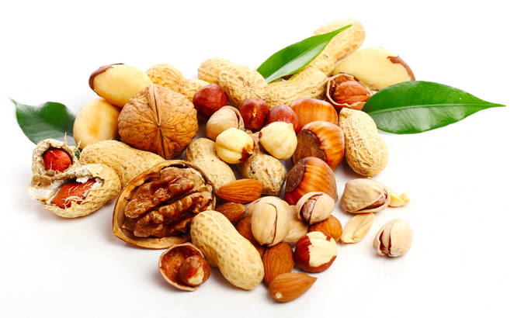

**2 Pork (Lean)**

Lean pork is another non-vegetarian source of vitamin B1. It provides 1.12 mg or 74% DV of vitamin B1 in a 100 grams serving. Other cuts of pork that contain significant amounts of vitamin B1 include lean pork loin (58% DV), lean pork tenderloin (57% DV) and lean pork chops (51% DV).

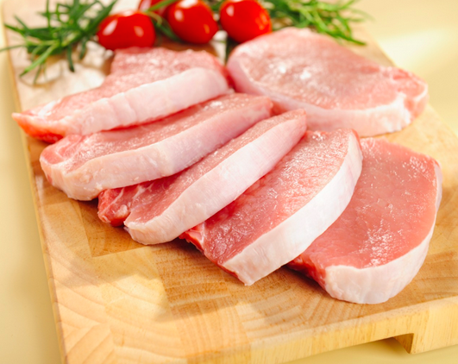

**3 Fish (Trout)**

Fish are known for its high concentration of omega-3 fatty acids. Most of the fish are good sources of vitamin B1 as well. Yellow fin tuna contains the highest levels of vitamin B1, contributing more that 35% of the daily requirement. Apart from this, trout fish provides 0.43 mg or 28% DV of vitamin B1 in a 100 grams serving. Other varieties include salmon (19% DV), shad (10% DV) and mackerel (9% DV). Hence, if you are a fan of seafood, you can consider having any of these fish on your meal plate to get the requisite amount of vitamin B1.

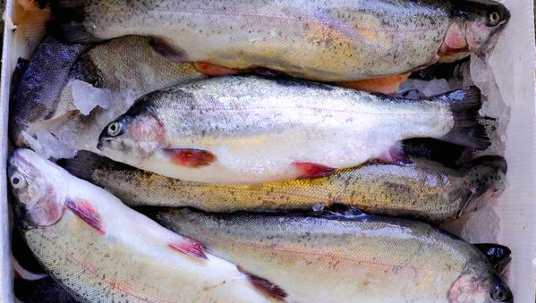

**4 Seeds (Sunflower)**

Various seeds are also good sources of vitamin B1. Sunflower seeds have the highest concentration of vitamin B1 providing 1.48 mg or 99% DV in a 100 grams serving. Sesame seeds come second with 100 grams serving providing 1.21 mg or 80% DV of vitamin B1. Other seeds that contain significant amounts of vitamin B1 include chia seeds (16% DV) and pumpkin and squash seeds (5% DV each).

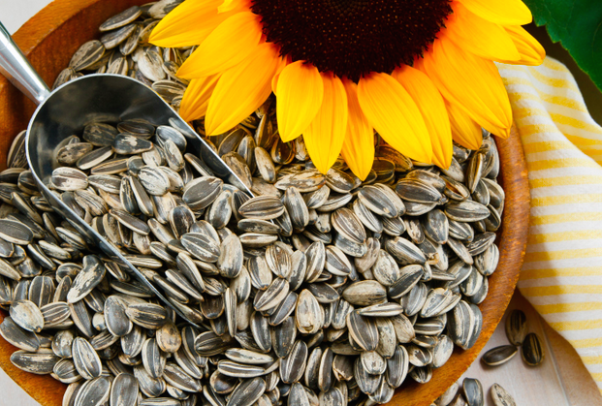

**5 Squash (Acorn)**

Squash is available in several varieties and some of them are good sources of vitamin B1. For instance, acorn squash is the best source providing 0.17 mg or 11% DV of vitamin B1 in a 100 grams serving. Other varieties include cooked butternut and Hubbard Squash each contributing 10% DV of vitamin B1 in a cup serving.

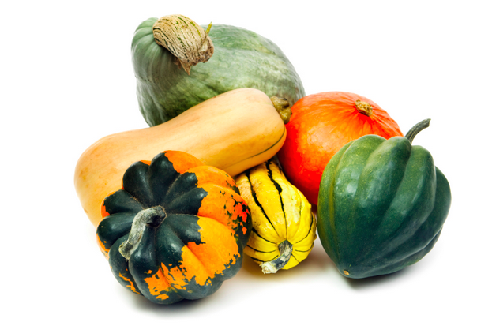

**6 Beans (Navy)**

All varieties of beans, including navy beans, black beans and pinto beans contain high levels of vitamin B1 as well as heart healthy proteins. The navy beans are the best sources providing 0.24 mg or 16% DV of vitamin B1 in a 100 grams serving. Other beans that are good sources of vitamin B1 include pink beans (29% DV), black beans (28% DV) and mung beans (22%).

**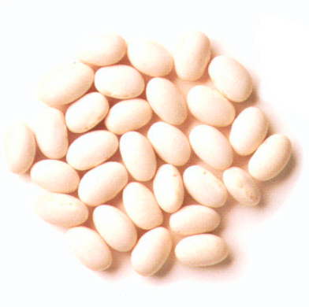**

**7 Bread (Wheat)**

Bread made from wheat flour also contains significant amounts of vitamin B1. A single slice of this bread provides 0.14 mg or 9% DV of vitamin B1. Other varieties of bread that are good sources of vitamin B1 include wheat bagel (26% DV), wheat English muffin (16% DV) and rye bread (9% DV).

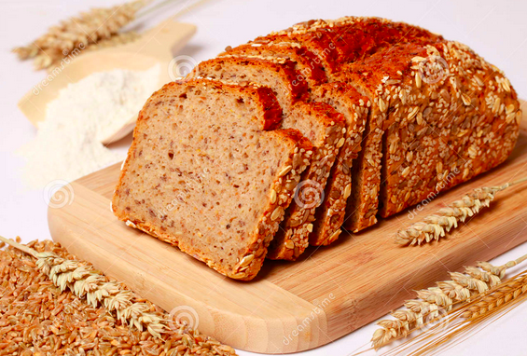

**8 Green Peas**

Even if you are a vegetarian, you need not worry about your vitamin B1 intake because there are certain vegetables that are good sources of this vitamin. Green peas are one such example, which provides 0.28 mg or 19% DV of vitamin B1 in a 100 grams serving. Fresh green peas are an excellent source contributing 28% DV in a cup serving while an equal amount of frozen sweet corn contributes 19% DV of vitamin B1.

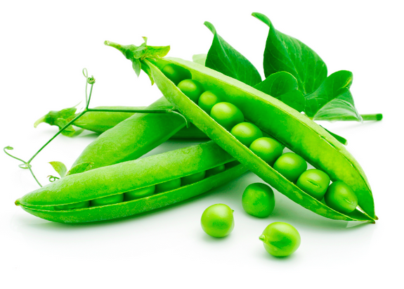

**9 Asparagus (Cooked)**

Among the green vegetables, cooked asparagus is a good source of vitamin B1. 100 grams serving of cooked asparagus provides 0.16 mg or 11% DV of this vitamin. Canned uncooked asparagus provides 5% DV in a half cup serving while an equal amount of cooked frozen asparagus contributes 4% DV of vitamin B1.

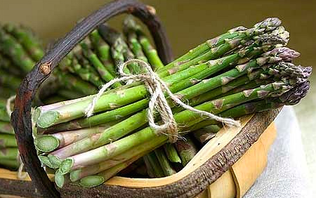

**10 Dry Roasted Soy Beans (Edamame)**

Apart from being rich in protein, dry roasted soybeans or edamame are a great source of vitamin B1, providing 0.43 mg or 28% DV of this vitamin in a 100 grams serving. However, it should be consumed in moderation as it is also high in calories. An ounce serving of edamame contains 126 calories.

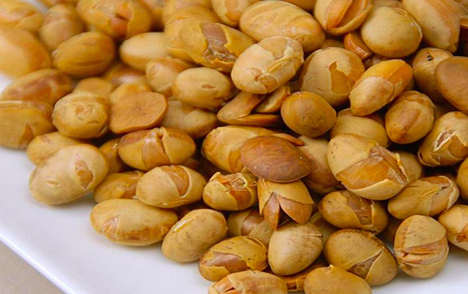

# Top 10 foods rich in Vitamin B7 (Biotin)

A biotin deficiency doesn’t occur very often, but not getting enough can leave your hair and skin in less than optimal condition. Getting enough biotin can also mean an increased metabolism, balanced blood glucose levels, and is simply one of the B Vitamins that you don’t want to be without for too long. Luckily it’s pretty easy to stay topped up on it, and very rarely will the average person run a shortage.

**Vitamin B7 helps the body to:**

A sufficient intake of vitamin B7 (Biotin) is important as it helps the body to convert food into glocose, which is used to produce energy, produce fatty acids and amino acids (the building blocks of protein) and activate protein/amino acid metabolism in th hair roots and fingernail cells

Deficiency of this vitamin can cause:

Vitamin B7 Deficiency is extremely rare, which is probably due to the fact that biotin is synthesized by benificial bacteria in the human digestive tract.

Groups at risk of biotin deficiency includes patients mained on total intravenous nutrition, hemodialysis patients, diabetes mellitus patients, and patients with an impaired uptake of vitamins from food. In addtion, pregnency may be associated with marginal biotin deficiency.

Syamptoms inlcludes hair loss, dry scaly skin, cracking in the corners of the mouth, swollen and painfultounge, dry eyes, loss of appetite, fatigue, insomnia and depression.

**Below is a list rich in Vitamin B7 (Biotin) foods**

1. Salmon  
Salmon often gets praise for its high levels of protein and omega-3 content, and it’s true that 20% of salmon is all protein. You’ll often see salmon used in sushi rolls, and it is also used as a main dish all by itself, served with a side of asparagus or broccoli as well as basmati rice or quinoa makes a complete meal. Many health experts suggest eating salmon multiple times per week for its anti-inflammatory properties. **Serving Size (100 grams), 208 calories, 20g protein.**

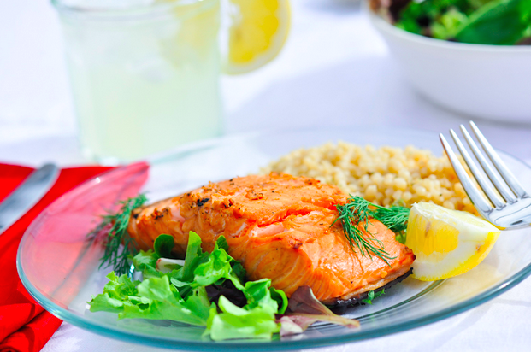

2. Mushrooms

Mushrooms are a healthy food overall, but if you’re concerned about your Biotin levels, you may want to be sure to include mushrooms in your cooking, or gravitate more towards menu items that include them. In addition to being a good source of Biotin, they bring with them a mix of healthy nutrients and minerals, and shouldn’t be overlooked as a healthy food. Try different types of mushrooms to see which you like best. **Serving Size (100 grams), 38 calories, 19% RDA of Iron.**

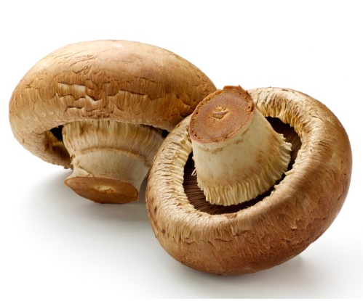

3. Turkey  
Not only is turkey a great way to get protein to help build lean muscle, it’s a source of Biotin and is one reason why most Americans do not run a Biotin deficit. As long as you’re sticking to skinless boneless turkey breast that’s been roasted you’ll be keeping the fat down, making this part of a healthy diet.

It’s nice that turkey is high in niacin because it’s readily available and is one of the most popular sandwich fillers in the country. Just be sure to go with roasted turkey breast so you avoid nitrates and added sodium that comes in deli meats. Turkey almost covers your daily requirement in one shot. **Serving Size (100 grams), Niacin (11.75 milligrams), 104 calories.**



4. Tuna  
Tuna is rich in Biotin, and also has plenty of other health benefits that make it worth adding to your diet a few times a week. You don’t want to consume too much of it, as many health experts say the mercury it contains can become a problem with frequent consumption. It’s a great source of protein and omega-3s as well so it does a lot for your body and your overall health goals. **Serving Size (100 grams),184 calories, full day’s supply of Vitamin B12.**

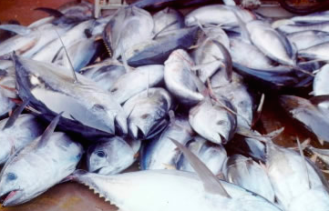

5. Avocados and Berries  
Avocados are full of so many vitamins, minerals, and other healthy things like protein and fiber, that it’s no surprise that you can use them for added Biotin. They provide a good portion of healthy fat as well, both monounsaturated and polyunsaturated, so no matter how you use them, in a recipe, on a salad, or on their own, you’re going to get a good boost of nutrition. **Serving Size (100 grams), 160 calories, 485mg of potassium.**

No matter which type of berry you go with, chances are high that you’ll be taking a big step towards getting enough Biotin. The added bonus is that most berries like blackberries, blueberries, and strawberries are high in antioxidants, which can help you stay healthy and ward off things like cancer and heart disease by protecting you from free radical damage.**Serving Size (100 grams), calories vary, rich source of vitamins.**

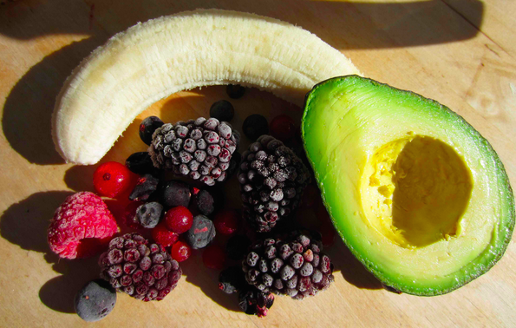

6. Liver  
Eating beef liver is not quite the same as eating beef, as it has loads more minerals in it, as well as additional vitamins, depending on the cut. You can be sure that you’re getting a good boost of Biotin when you eat liver. It’s also a rich source of iron and magnesium but perhaps not as readily available as some beef. Visiting a butcher shop may be your best bet. **Serving Size (100 grams), 516 calories, 4g total fat.**

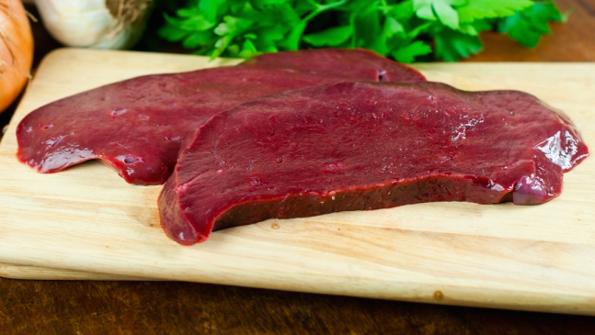

7. Eggs

Egg yolk is another excellent biotin rich food. However, too much egg white can actually be a catalyst for a biotin deficiency as eggs contain a specific element that binds biotin to a protein called avidun, reducing the ability to equally distribute the nutrient.

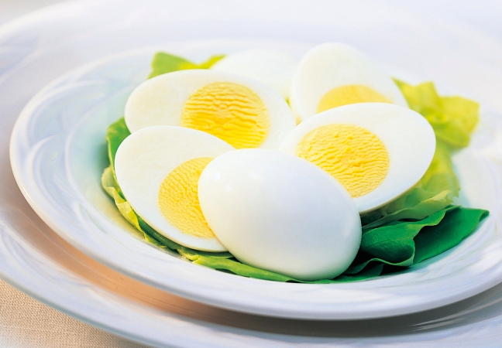

8. Whole Wheat Bread

Whole wheat bread is often considered a healthier substitute for white bread, but these days it is also being held under the microscope because of the gluten it contains. Be that as it may, it’s also a good source of Biotin and can help you reach your grand total for the day. It’s a surprising source of protein as well as iron, but can also be trouble on a carb conscious diet. **Serving Size (100 grams), 270 calories, 10 grams protein.**

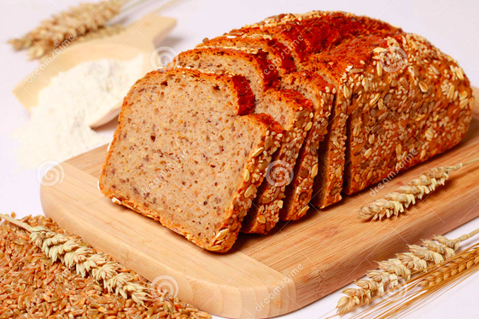

9. Almonds  
Almonds make a great anytime anywhere snack and since they provide such a nice crunch they can help you kick junk food cravings like potato chips. They’re an excellent source of Biotin, have plenty of calcium, as well as healthy fats. Just be sure to keep your portions to a handful, since these can pack a lot of calories into a small portion. **Serving Size (100 grams), 576 calories, 72% RDA of calcium.**

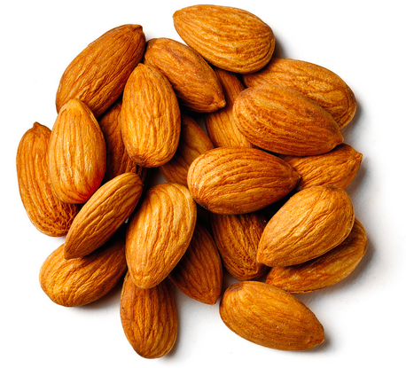

10. Beef  
The slogan for beef is that it’s “what’s for dinner” and if you’re trying to keep your Biotin levels steady it’s not such a bad idea. In addition to a respectable amount of protein and other minerals, it’s also provided you with Biotin. As long as you keep your portion sizes in check and stick with lean cuts of beef, you’ll be getting all of these benefits with few drawbacks. **Serving Size (100 grams), 332 calories, 14g of protein.**

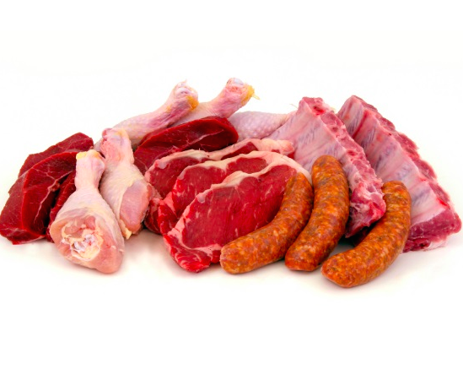

# Top 10 Foods rich in Vitamin B6 (Pyrodoxine)

Vitamin B-6 (pyridoxine, pyridoxal, pyridoxamine) is a water soluble vitamin necessary for the proper maintenance of red blood cell metabolism, the nervous system, the immune system, and many other bodily functions. Over time, a deficiency in vitamin B-6 can lead to skin inflammation (dermatitis) depression, confusion, convulsions, and even anemia. Recent studies also suggest that a diet low in vitamin B6 increases risk of heart attack. Conversely, too much vitamin B6 taken from supplements can lead to nerve damage in the arms and legs. The DV for vitamin B6 is 2mg per day.

**Vitamin B6 helps the body to:**

Make antibodies. Antibodies are needed to fight many diseases.

Maintain normal nerve function

Make hemoglobin. Hemoglobin carries oxygen in the red blood cells to the tissues. A vitamin B6 deficiency can cause a form of anemia.

Break down proteins. The more protein you eat, the more vitamin B6 you need.

Keep blood sugar (glucose) in normal ranges.

**Deficiency of this vitamin can cause:**

Confusion

Depression

Irritability

Mouth and tongue sores

**Below is a list rich vitamin B6 foods**

**1: Sunflower Seeds**

Even if you are a vegetarian, you need not worry about your vitamin B6 intake as there are several varieties of seeds that are rich sources of this vitamin. Among these, sunflower seeds are the best with 100 grams serving providing 1.35 mg or 67% DV of this vitamin. Other seeds that contain vitamin B6 include sesame seeds (11% DV), flaxseeds (7% DV) and pumpkin & squash seeds (2% DV) each in an ounce serving. So munch on these seeds as snacks or add them to popular recipes to increase your vitamin B6 intake!



**2: Pistachio Nuts**

In terms of diet and fitness, pistachios have the lowest calorie count and are the least fattening relative to all other nuts. On average, an ounce of pistachios (about 28 nuts) contains about 160 calories and 13 grams of fat. To get the maximum dietary benefit, make sure you buy them unsalted and dry roasted.

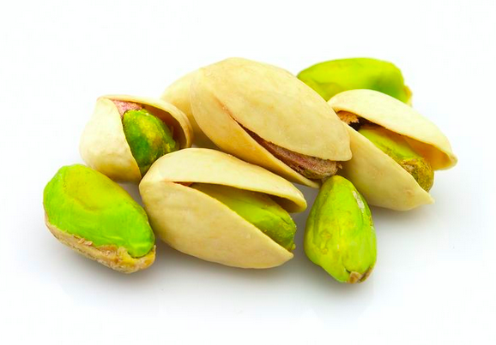

**3: Fish (Tuna, Cooked)**

Just like meat, certain varieties of fish are excellent sources of vitamin B6. Yellowfin tuna is one of the best dietary sources of vitamin B6 with 100 grams serving providing 1.04 mg or 52% DV of this vitamin. Other varieties of fish that are rich sources of vitamin B6 include wild salmon (40% DV), salmon (29%), halibut (27% DV), swordfish (26% DV) and herring (22% DV). Apart from vitamin B6, they are also good sources of heart healthy monounsaturated fats.



**4: Turkey & Chicken (Turkey, Light Meat, Cooked)**

Other non-vegetarian sources of vitamin B6 include chicken and turkey. A 100 grams serving of chicken or turkey contains 0.81 mg or 40% DV of vitamin B6. Other similar varieties of poultry that are high in vitamin B6 include fat free ground turkey (46% DV), chicken breast (28% DV) and chicken wing (26%). Chicken and turkey are extremely light and can be easily incorporated in simple recipes and snacks like sandwiches.



**5: Lean Pork (Sirloin, Cooked)**

Cooked lean pork is also a good source of vitamin B6 with 100 grams serving providing 0.79 mg which is equivalent to 39% DV of this vitamin. Other pork varieties that contain significant amounts of vitamin B6 include ground pork (36% DV), pork tenderloin (31% DV) and pork chops (30% DV).



**6: Dried Fruit (Prunes)**

Apart from fruits, certain dried fruits are great sources of vitamin B6. A 100 grams serving of dried prunes contains 0.75 mg or 37% DV of vitamin B6. Other dried fruits that contain this vitamin include dried apricots (16% DV) and raisins (14% DV) in a half cup serving. Thus, you can replace those unhealthy sugary snacks with these dried fruits for a nutrition boost.

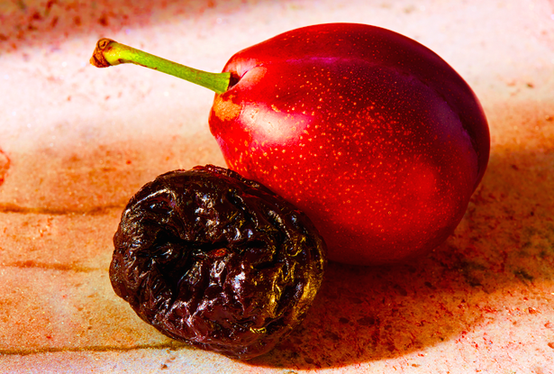

**7: Lean Beef (Rib, Cooked)**

Vitamin B6 is commonly found in meats. Lean beef is an amazing source, providing 0.68 mg or 34% DV of vitamin B6 in 100 grams serving. Other beef varieties that are good sources of vitamin B6 include sirloin steak (29% DV) and filet steak and rib eye (28% DV). You can boost your vitamin B6 levels by incorporating beef in simple recipes.

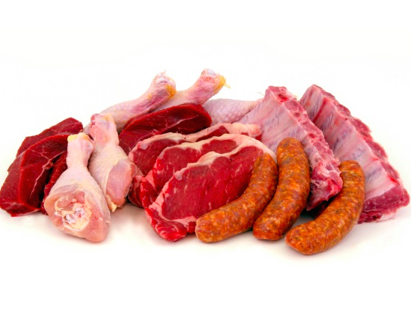

**8: Bananas**

Among the fruits, bananas are particularly rich in vitamin B6. A medium sized banana contains 0.43 mg or 22% DV of vitamin B6. It is high in calories containing 105 calories, but it contains just 0.39 grams fat. You can eat this yummy fruit directly or blend it into a smoothie. Being high in calories, it also provides an energy boost.

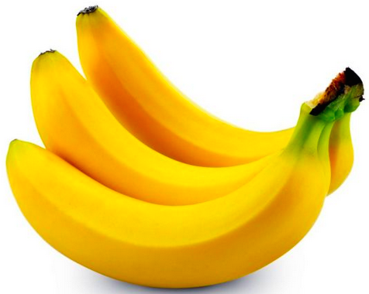

**9: Avocado**

Avocados are other fruits that are rich sources of vitamin B6. A single avocado contains 0.39 mg, contributing 20% of the DV of vitamin B6. But it should be consumed in moderation as it is high in calories with just half an avocado containing 114 calories and 1.4 grams saturated fat.

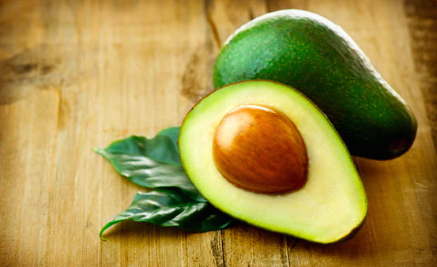

**10: Spinach (Cooked)**

Most of the vegetables contain high levels of vitamin B6 and spinach is one of them. A serving of 100 grams cooked spinach provides 0.24 mg or 12% of the daily value (DV) of vitamin B6. It is also a healthy option for your diet as a cup of cooked spinach contains just 41 calories and 0.47 grams fat. Other veggies that contain significant levels of vitamin B6 include broccoli, bell peppers, baked potatoes, green peas, yam and turnip greens.

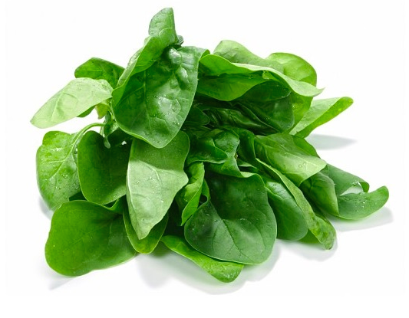

# Top 10 Foods rich in Vitamin B5 (Pantothenic Acid)

Vitamin B5, or Pantothenic Acid, is an essential vitamin required by the body for cellular processes and optimal maintenance of fat. A deficiency of vitamin B5 is rare, however, when it does occur is usually seen in the form of irritability, fatigue, apathy, numbness, paresthesia, and muscle cramps. It can also lead to increased sensitivity to insulin, or hypoglycemia. Pantothenic Acid, Vitamin B5, is a water soluble vitamin that is well regulated by the body, thus overdose is rare, and may only be noticed in the form of slight digestive complaints or diarrhea. The current DV for Pantothenic Acid (Vitamin B5) is 10mg.

**Vitamin B5 helps the body to:**

Vitamin B5 plays an important role in helping release energy from sugars, starches, and fats.

Vitamin B5 is important for releasing energy stored as fat, it is equally important for the creation of fat. Two basic types of fats - fatty acids and cholesterol - both require the CoA form of B5 for their synthesis.

Sometimes it is important for the body to make small chemical changes in the shape of cell proteins, thus vitamin B5 is useed in this case.

They are essential for the cell metabolism.

They are very helpful in the cholesterol metabolism.

**Deficiency of this vitamin can cause:**

Drinkers are more prone to get deficient in vitamin B5.

Deficiency of vitamin B5, can be seen in the womens, who are on the pill.

People on antibiotics

Deficiency of vitamin B5, can be seen in peoples, who are on sleeping pills.

People who drink a lot of caffeine e.g. from coffee, tea or soft drinks.

In the unlikely event of a Vitamin B5 deficiency, those affected may have the following symptoms: overall weakness, muscle cramping, insomnia and fatigue, intestinal problems such as water retention, nausea, vomiting or diarrhea, a low resistance to infection or a tingling sensation in the extremities.

With Vitamin B5 in short supply symptoms like fatigue, headaches, nausea, tingling in the hands, depression, personality changes and cardiac instability have been reported.

**Below is a list rich in vitamin B5 foods:**

**1: Mushrooms (Shiitake, Cooked)**

Mushrooms are naturally occurring foods that contain several nutrients, vitamin B5 being one of them. Shiitake mushrooms have the highest levels of pantothenic acid with 100 grams serving providing 3.59 mg or 36% of the daily value (DV) of this vitamin. Other varieties of mushrooms that are good sources of vitamin B5 include cooked white mushrooms (34% DV), grilled portabella (15% DV), raw brown mushrooms, oyster mushrooms (11% DV) and raw chanterelle (6% DV) in a cup serving. You can make mushrooms a part of your diet to boost your vitamin B5 levels. However, since some mushrooms grow in the wild, avoid eating poisonous varieties if you pick them from the wild.

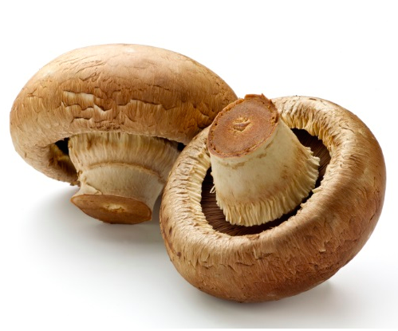

**2: Cheese (Gjetost)**

Cheese comes in several varieties and is widely used in sandwiches, pizzas and other recipes. Being a dairy product, it is considered quite nutritious. Among the cheese varieties, Gjetost is the best source of vitamin B5 providing 3.35 mg or 34% DV in a 100 grams serving. Other varieties of cheese that contain vitamin B5 in smaller amounts include Roquefort and blue cheese (5% DV), camembert (4% DV) and feta (3% DV) in an ounce serving.

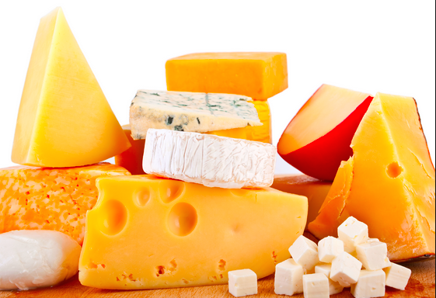

**3: Oily Fish (Trout, Cooked)**

Fish is known for its amazing nutritional value. Besides being rich in omega-3 fatty acids, oily fish is also a great source of vitamin B5. Trout fish is the best in this regard with 100 grams serving providing 2.24 mg or 22% DV of vitamin B5. Other oily fish that contain abundant amounts of vitamin B5 include rainbow trout (17% DV), wild salmon (16% DV), farmed salmon (13% DV) and tuna (12% DV) in a 3 oz. serving.

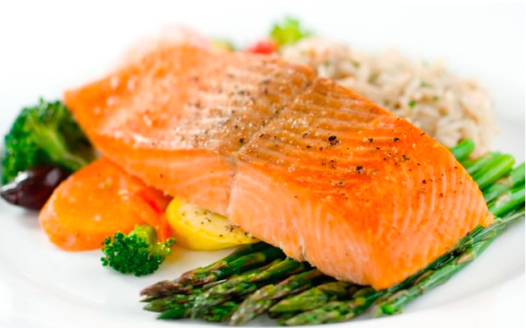

**4: Avocados**

Avocados are full of so many vitamins, minerals, and other healthy things like protein and fiber, that it’s no surprise that you can use them for added Vitamin B5. They provide a good portion of healthy fat as well, both monounsaturated and polyunsaturated, so no matter how you use them, in a recipe, on a salad, or on their own, you’re going to get a good boost of nutrition. **Serving Size (100 grams), 160 calories, 485mg of potassium.**



**5: Eggs**

Eggs are another popular foods rich in vitamin B5. They are an excellent source of protein. A single cooked egg provides 0.70 mg or 7% DV of vitamin B5. Indeed, a good way to increase your vitamin B5 intake is to have scrambled or boiled eggs for breakfast.  
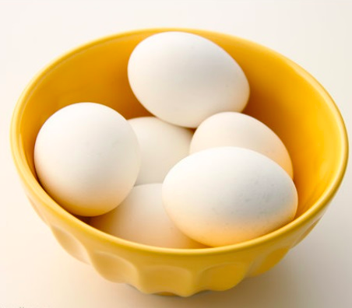

**6: Lean Pork (Sirloin, Cooked)**

Lean pork is another important non vegetarian source of vitamin B5. A serving of 100 grams cooked lean pork sirloin provides 1.65 mg or 17% DV of this vitamin. Similarly, there are other cuts of pork that are rich in vitamin B5 such as lean ribs & lean loin of pork, lean shoulder of pork and lean ground pork contributing 14%, 12% and 7% DV of this vitamin respectively.



**7: Beef & Veal (Veal Shoulder, Cooked)**

Beef and beef cuts are also good sources of vitamin B5. A piece of cooked veal shoulder contains 2.93 mg or 29% DV of pantothenic acid. Other beef cuts that are good sources of vitamin B5 include rib of veal (12% DV), veal sirloin (11% DV) and lean beef steak (12% DV) in a 3 oz. serving. Calf liver is also densely packed with vitamin B5, but it is rare and difficult to cook.

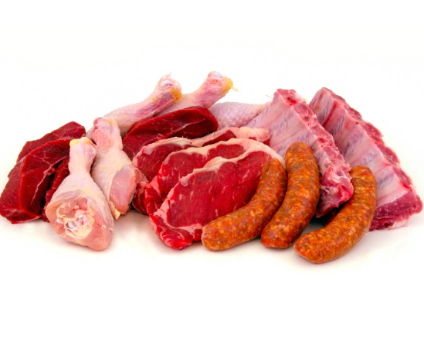

**8: Chicken & Turkey (Chicken Drumstick, Cooked)**

Chicken and turkey are popular food items. They are also rich in vitamin B5. A single cooked chicken drumstick provides 0.55 mg or 6% DV of vitamin B5. Other poultry that contain pantothenic acid include Chicken leg and thigh (11% DV), turkey leg (10% DV), chicken breast (9% DV) and turkey light meat (8% DV). Chicken and turkey are quite versatile and can be used in sumptuous meals as well as sandwiches and burgers.



**9: Sunflower Seeds**

Sunflower seeds are not only a popular snack but are also loaded with vitamins and minerals including vitamin B5. A 100 grams serving of sunflower seeds contain 7.06 mg or 71% DV of this vitamin. Certain other seeds also contain vitamin B5 such as flaxseeds, pumpkin & squash seeds, contributing 9% and 2% DV of this vitamin respectively.



**10: Sweet Potato (Baked)**

Sweet potato is enjoyed widely for its delightful taste and high nutrient content. It is arguably the best source of vitamin B5. A cup of cooked, frozen sweet potato provides 578% of the daily value of vitamin B5, while canned sweet potato provides 444%. This low calorie vegetable adds just 103 calories to your diet. Slice the sweet potatoes and drizzle olive oil, salt, pepper and chili powder. Roast at 400 degrees for 20 minutes and the delicious sweet potato chips are ready to eat.

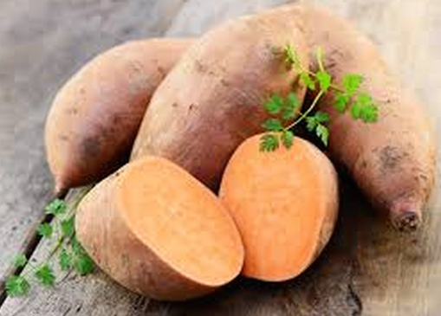

# Top 10 Foods rich in Vitamin B3 (Niacin)

Vitamin B3, is also called Niacin or nicotinic acid, which can be manufactured by the body. Niacin is derived from two compounds - nicotinic acid and niacinamide. It is a water soluble vitamin. It help the body to convert carbohydrates into glucose, which is "burned" to produce energy. Vitamin B3, also play an important role in maintaining muscle tone along the digestive tract.

Vitamin B3 is required for cell respiration, helps in the release of energy and metabolism of carbohydrates, fats, and proteins, proper circulation and healthy skin, functioning of the nervous system, and normal secretion of bile and stomach fluids. It is used in the synthesis of sex hormones, treating schizophrenia and other mental illnesses.

**Vitamin B3 helps the body to:**

* Vitamin B3 helps in releasing energy from carbohydrates, fats and proteins.
* Vitamin B3 is very essential for the DNA synthesis.
* Niacin is commonly used to lower elevated LDL cholesterol and triglyceride levels in the blood and is more effective in increasing HDL levels than other cholesterol-lowering medications.
* It is also helpful in reducing migraine headaches.
* Vitamin B3, as niacinamide, may improve arthritis symptoms, including increasing joint mobility and reducing the amount of anti-inflammatory medications needed.
* It is necessary for healthy skin, nerves and digestive system.
* High doses of niacin medications are used to prevent development of atherosclerosis and to reduce recurrent complications such as heart attack and peripheral vascular disease in those with the condition.
* It helps to detoxify the body.
* Vitamin B3, is very essential for the proper digestion of the food.

**Deficiency of this vitamin can cause:**

* Loss of appetite is the early symptom of the deficiency of vitamin B3.
* Indigestion, may be occur due to deficiency of vitamin B3.
* Skin lesions may be seen in some cases.
* Mental imbalance can occur due to deficiency of vitamin B3.

A deficiency of vitamin B3, may cause pellagra, the classic niacin deficiency disease, and is characterized by bilateral dermatitis, diarrhea, and dementia.

**Below is the list rich in vitamin B3 (Niacin):**

**1: Fish (Cooked Yellowfin Tuna)**

Good news if you already consume tuna on a regular basis, it’s high in niacin compared to many other foods. It’s also a good source of omega-3s as well as protein. There are concerns about the mercury content, so you may not want to rely on tuna for your daily niacin consumption, but it’s nice to have once in awhile. **Serving Size (100 grams), Niacin (5.8milligrams), 184 calories.**



**2: Chicken & Turkey (Cooked Chicken Breast)**

The reason most Americans don’t have a problem getting enough niacin is that chicken is the most widely consumed meat, and contains plenty of niacin. A serving of chicken gets you roughly halfway to what you need for the day, which means if you have chicken at one meal and another meat source on this list for the other meal, you should be totally covered.**Serving Size (100 grams), Niacin (7.8 milligrams), 172 calories.**

It’s nice that turkey is high in niacin because it’s readily available and is one of the most popular sandwich fillers in the country. Just be sure to go with roasted turkey breast so you avoid nitrates and added sodium that comes in deli meats. Turkey almost covers your daily requirement in one shot. **Serving Size (100 grams), Niacin (11.75 milligrams), 104 calories.**



**3: Pork (Cooked Lean Chop)**

Pork comes in third on the rank of most consumed meats, behind chicken and beef, but its niacin ranks higher than both of those. It’s fine to include pork in your regular lineup of foods, having it a few times per week as part of a healthy diet works as long as you keep it to lean cuts to keep the fat down. **Serving Size (100 grams), Niacin (15 milligrams), 179 calories.**



**4: Liver (Cooked Lamb Liver)**

Organ meats score high in terms of their nutritional value and vitamin B3 is one of them. Liver is an excellent source with a single cooked lamb liver providing a whopping 53.7 mg or 269% DV of niacin. Other livers that are high in niacin include beef (75% DV), veal (61% DV), chicken (57% DV) and (pork 36% DV).

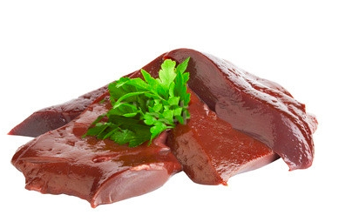

**5: Peanuts (Oil Roasted)**

NIACIN helps convert food to energy. The digestive system, skin, and nerves also use niacin to function. Further, research shows that dietary niacin may protect against Alzheimer’s disease and cognitive decline (Morris, 2004). An ounce of peanuts is an excellent source of niacin providing a quarter of our daily needs.

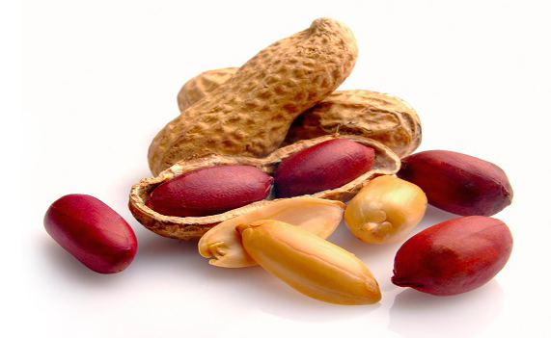

**6: Beef (Cooked Lean Rib)**

Beef is another great source of vitamin B3 providing 9 mg or 45% DV in a 100 grams serving of cooked lean rib. Other beef cuts that are good sources of niacin include lean sirloin steak (38% DV), beef fillet (37% DV) and tenderloin (36% DV) in a 3 oz. serving.

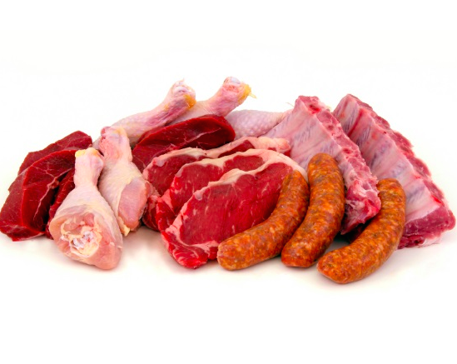

**7: Mushrooms (Grilled Portobello)**

All types of mushrooms are rich in vitamin B3. Shiitake mushrooms are the best with 100 grams serving providing 14.1 mg or 71% DV of niacin. They also possess anti-cancer properties. A 100 grams serving of grilled Portobello provides 6.3 mg or 31% DV of vitamin B3. Other mushrooms that contain significant amounts of niacin include cooked white mushroom (35% DV), raw oyster (21% DV), raw brown mushroom (14% DV) and raw chanterelle (11% DV).

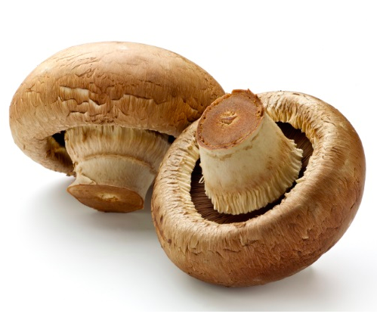

**8: Green Peas (Fresh)**

Vegetarians need not worry about their vitamin B3 intake as there are plenty of vegetarian foods rich in this vitamin, green peas being one of them. A serving of 100 grams fresh green peas provides 2.1 mg or 10% DV of niacin. Similarly a cup of cooked frozen peas and canned peas contribute 12% and 8% DV of niacin respectively. They are also good sources of protein. Besides, they are quite versatile and can be added to any recipe to boost your vitamin B3 levels.

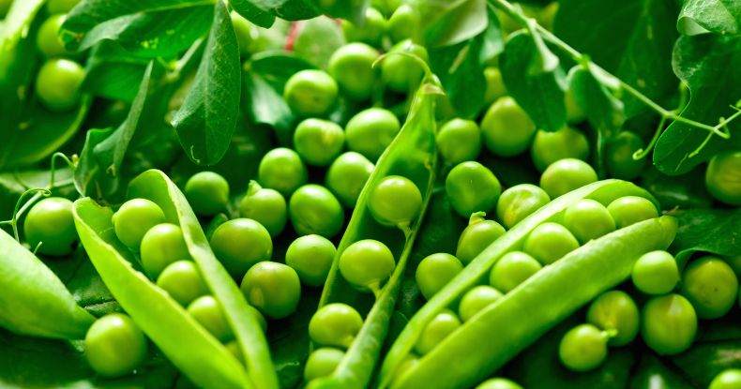

**9: Sunflower Seeds**

**Niacin and pyridoxine** are other B-complex vitamins found abundantly in the sunflower seeds. About 8.35 mg or 52% of daily-required levels of niacin is provided by just 100 g of seeds. Niacin helps reduce LDL-cholesterol levels in the blood. In addition, it enhances GABA activity inside the brain, which in turn helps reduce anxiety and neurosis.

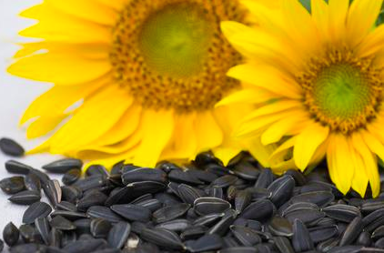

**10: Avocado**

Among the fruits, avocado is a good source of vitamin B3. A single avocado provides 3.5 mg or 17% DV of niacin. However, it should be consumed in moderation as it is also high in calories. Just half an avocado contains 160 calories.



# Top 10 Foods rich in Vitamin B2 (Riboflavin)

Vitamin B2, is also called Riboflavin, which is manufactured in the body by the intestinal flora and is easily absorbed. It is a member of the B-complex family. Small amounts of this water soluble vitamin are in practically every type of plant and animal tissue. Vitamin B2 is responsible for several important bodily functions including assisting with the metabolization process of proteins, fats and carbohydrates.

Vitamin B2 helps the body to:

* Vitamin B2, helps in converting carbohydrate into energy and this energy is utilised by the body.
* It is very useful for normal tissue respiration.
* Necessary for healthy mucous membranes
* Good for skin, nails and eyes
* It helps in protects the body against cancer.

**Deficiency of this vitamin can cause:**

* Ther symptoms that may occur, due to the deficiency of vitamin B2 are as: red, swollen, cracked lips, mouth and tongue, aversion to bright light, loss of appetite, weakness, fatigue, depression, anemia, loss of vision, burning and itching of the eyes.
* Vitamin B2 deficiency by itself is uncommon. It usually occurs with deficiencies of other B vitamins in people who have a protein and calorie deficiency.
* Chronic disorders, such as heart disease, cancer, and diabetes mellitus, and malabsorption disorders increase the risk of vitamin B2 deficiency.

**Below is a list high riboflavin foods:**

**1: Cheese**

Cheese is also a good source of vitamin B2. There are several varieties of cheese of which Gjetost is the best with 100 grams serving providing 1.38 mg or 81% DV of vitamin B2. Other varieties of cheese that are good sources of riboflavin include hard goat cheese (20% DV), feta (14% DV), Roquefort (10% DV), Brie (9% DV), camembert and grated parmesan (8% DV).



**2: Almonds**

Almonds make a great anytime anywhere snack and since they provide such a nice crunch they can help you kick junk food cravings like potato chips. They’re an excellent source of Biotin, have plenty of calcium, as well as healthy fats. It is a great sounce of vitamin E, protein, calcium, zinc, magnesium, Pattasium, and copper. Along with these nutrients , it is a good sounce of vitamin B2 or Riboflavin. Just be sure to keep your portions to a handful, since these can pack a lot of calories into a small portion. **Serving Size (100 grams), 576 calories, 72% RDA of calcium.**

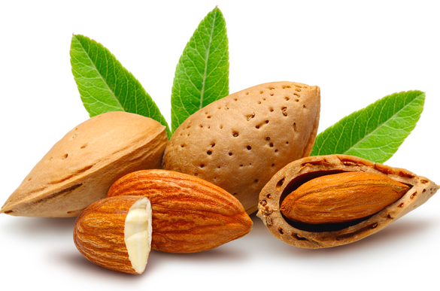

**3: Beef & Lamb (Lean Steak)**

As far as meats are concerned, beef contains a lot of vitamin B2 along with other B-complex vitamins. A single lean steak contains 1.51 mg or 89% DV of this vitamin. Lamb is also a good source of riboflavin with a 3 oz serving of cooked lamb leg providing 21% DV of this vitamin. This is followed by veal which provides 20% DV of vitamin B2. Beef liver is also a good choice for increasing your intake of vitamin B2 and other vitamins.

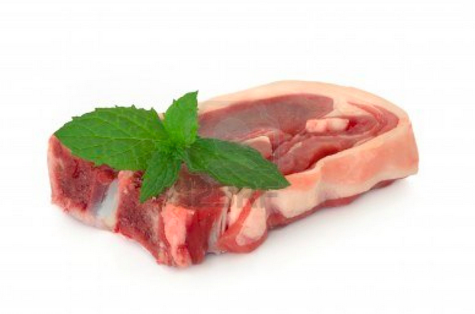

**4: Oily Fish (Mackerel)**

Oily fish is a rich source of vitamins as well as omega-3 fatty acids. As far as vitamin B2 is concerned, mackerel is the best source providing 0.58 mg or 34% DV of this vitamin in a 100 grams serving. Other oily fish also contain significant amounts of vitamin B2 such as smoked salmon (27% DV), wild salmon (24% DV), trout (21% DV), tuna and herring (15% DV) and salmon (11% DV) in a 3 oz. serving. So, ensure to have fish at least once in a week to boost your vitamin B2 intake.

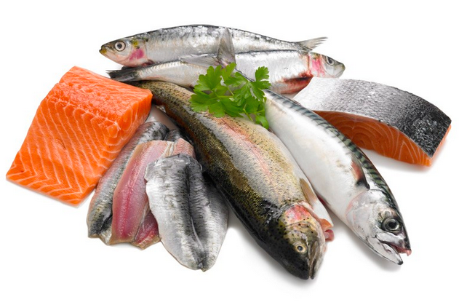

**5: Egg (Hard Boiled)**

Eggs are an amazing source of protein and other nutrients, vitamin B2 being one of them. A single hard-boiled egg provides 0.26 mg or 15% DV of riboflavin. Similarly, raw, fried or scrambled egg provides 13% DV while poached egg provides 11% DV of vitamin B2. Thus, a great idea to improve your vitamin B2 intake is to have an egg on your breakfast plate.

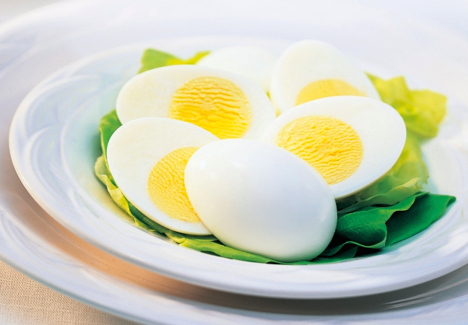

**6: Pork (Sirloin)**

Pork is an excellent source of B-vitamins and vitamin B2 is no exception. A piece of lean pork sirloin contains 3.11 mg which is equivalent to 183% DV of vitamin B2. Other varieties of pork that contain significant amounts of riboflavin include ground pork (24% DV), pork shoulder (23% DV) and pork loin (22% DV).



**7: Mushrooms**

Mushrooms are available in several varieties which contain varying amounts of vitamin B2. A serving of 100 grams raw brown Italian mushrooms contains 0.49 mg or 29% DV of vitamin B2. Other varieties of mushrooms that contain significant amounts of vitamin B2 include stir fried white mushrooms (29% DV), grilled Portabella (29% DV) and dried shiitake (22% DV) in a serving of 8 mushrooms.

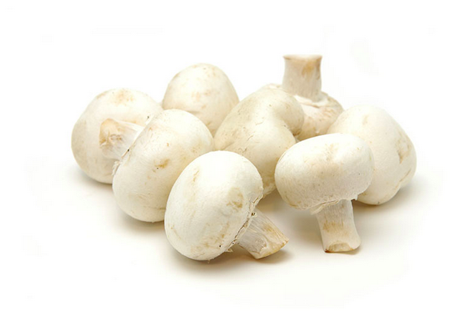

**8: Sesame Seeds**

Icluding sesame seedsin your food is a agreat way to furnish your body with essential minerals and vitamins. It contains high amount of calcium, iron, copper,zinc, viatmin B1 and B6. Besides these nutients , it is alos rich in source of vitamin B2. Semame seeds conatins around 0.47 mg of vitamin B2 per 100gm serving.

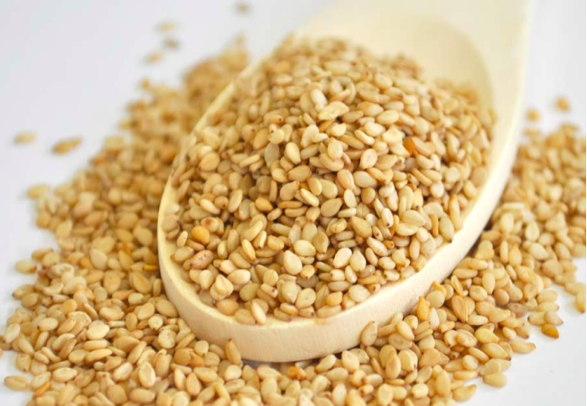

**9: Seafood (Squid)**

Frequencu and duration of migrane are lowered due to the presence of B2 (Riboflavin) in plentiful quantities, in squids. Research indicates that riboflavin supplements are a good remedy for the prevention of migrane.

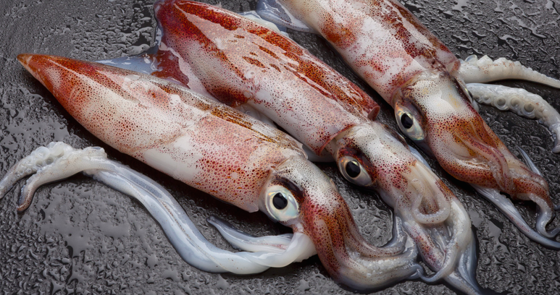

**10: Spinach**

Spinach is a super food when we talk about its nutritional value. It is also quite a good source of vitamin B2 with 100 grams serving providing 0.24 mg or 14% DV of riboflavin. Other green vegetables that are high in riboflavin include beet greens (24% DV), asparagus (14% DV), drumstick leaves (13% DV), collard greens (12% DV), dandelion greens (11% DV) and broccoli (8% DV). Thus, you can have a dish of steamed vegetables or enjoy them in salads to get the recommended amount of nutrients including vitamin B2.

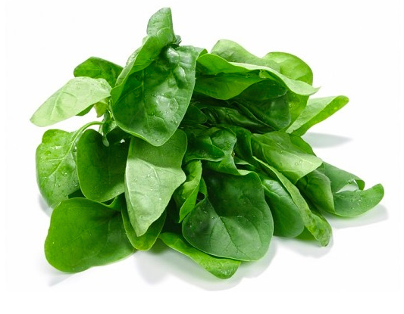

# Top 10 Foods rich in Vitamin B9 (Folic Acid)

**Folic acid is a form of the water-soluble vitamin B9. Folic acid is a key factor in the making (synthesis) of nucleic acid - nucleic acid is one of a family of large molecules including DNA (deoxyribonucleic acid) and RNA (ribonucleic acid)**. Folate occurs naturally in food, and folic acid is the synthetic form of this vitamin.

Vitamin B9, is required for energy production, formation of red and white blood cells. As a brain food, Vitamin B9 assists in regulating mood and sleep patterns, particularly in older persons.

Folic acid helps the body to:

* Folic acid participates in several important metabolic processes in the body.
* It is essential for the **normal growth and maintenance of all cells**because it acts as a **coenzyme for normal DNA and RNA synthesis**. It also produces nucleic acids, RNA(ribonucleic Acid) and DNA(Deoxyribonucleic Acid),that carry hereditary patterns.
* In fact,eating fresh fruits and vegetables rich in folate, from conception until the due date, is the best policy a woman can adopt to ensure that her pregnancy will be  a happy and a healthy one.
* It aids in protein metabolism and contributes to normal growth.
* It is also very **vital vitamin for the reproduction of the cells within the fetus**. A deficiency affects normal cell division and protein synthesis, especially impairing growth.

**Deficiency of this vitamin can cause:**

* Fatigue, tiredness
* Feeling generally weak
* Forgetfulness
* Being irritable, easy irritated
* Loss of appetite
* Weight loss.

**Below is a list rich in Vitamin B9 (Folic Acid):**

### 1. Lettuce and green leafy vegetables:

Dark green leafy vegetables are the healthiest foods on the planet. For a quick boost in your folic acid level, consider adding more of spinach, collard, arugula, kale, lettuce and turnip greens in your diet. A plate of these greens will provide you with your daily need of folate. A serving of spinach provides 26 micrograms, collard greens provide 177 micrograms and turnip greens provide 170 micrograms of folic acid. A cup of arugula will benefit your body with 19 micrograms of folic acid. Green leafy vegetables also come packed with zinc, iron, calcium, potassium and all the vitamins. Combine it with avocado, soybeans and avocado for a strong punch of folic acid.

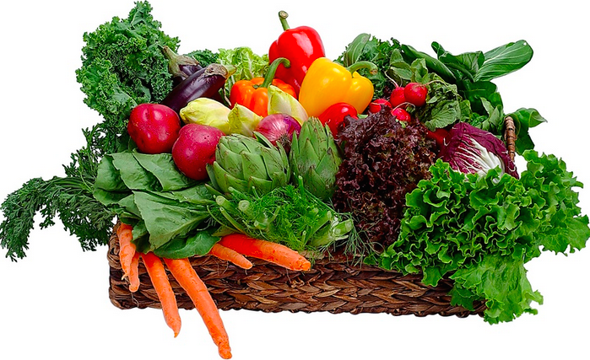

### 2. Asparagus:

This woody treat is perhaps one of the most nutrient dense foods in the entire vegetable kingdom. This low calorie vegetable has been used as a medicine since time unknown. Four stalks of asparagus provide 90 micrograms of folic acid, around 22% of the daily value. These spears also provide the body with all the nutrients it craves for like vitamin A, C, K and manganese.



### 3. Broccoli:

Broccoli is one of the best detoxifying foods you can eat. A half-cup serving of broccoli provides you with 52 micrograms of folic acid, amounting to 13% of what an average adult needs per day. You can eat broccoli both raw and cooked. This cruciferous vegetable will make a great addition to salads or pasta. Alternatively, you can combine it with meat to make a sumptuous side dish. Broccoli is low in calories too. It contains just 26 calories per ½ cup serving.

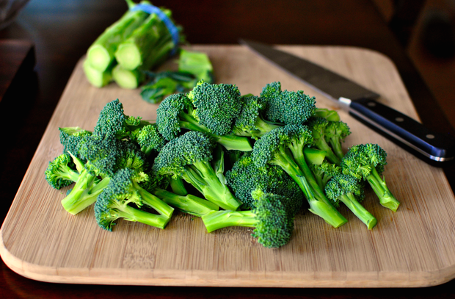

### 4. Nuts and Seeds:

Seeds like pumpkin, sesame, sunflower and flax seeds will give you a healthy dose of folic acid. ¼ cup of sunflower seed contains 82 micrograms of folic acid and 2 tablespoons of flax seeds contains 54 micrograms of folate. Seeds also provide you with beneficial fats and essential nutrients like vitamin A, E, omega 3 fatty acids and cancer preventing lignans. Add a handful of seeds to your smoothies, oats or cereal or eat them raw or roasted.

Not many are aware, but peanut is a good source of folic acid too. A half cup of peanuts is filled with 106 micrograms of folic acid, a quarter of what an average person needs in a day. Peanuts will also provide you with zinc, copper, protein and magnesium.

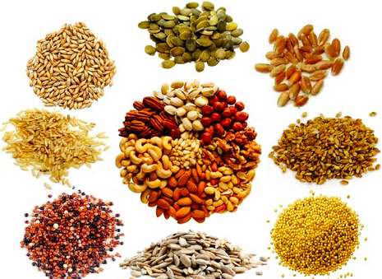

### 5. Liver:

Both turkey and beef liver are good sources of folic acid. 100 grams of turkey liver contain more than the recommended amount of folic acid, around 691 micrograms. A 3 oz. serving of beef liver supplies the body with 215 micrograms of folate. Pregnant women can get their daily value of folic acid with just one serving of beef liver. You can add liver to stuffing or make gravy out of it.



### 6 Avocado:

Avocados are one of the best foods to meet your daily folic acid need. A single avocado provides 162 micrograms of folic acid, around 41% of the daily value. Not only is avocado a good source of folic acid, but it also provides potassium, vitamin C, fatty acids, phosphorus and antioxidants. Add them to your sandwiches, salads or prepare a delicious dip out of it.



### 7 Bananas:

Fruits high in folic acid are completely safe for consumption by the pregnant women. A medium sized banana contains 23.6 of folic acid, equaling to 6% of the daily value of folic acid. It also provides the body with fiber, protein and potassium. The best part is that you can enjoy a banana at any time of the day. So grab a banana to get small, yet useful amount of folic acid.



### 8 Papaya:

This colorful fruit is as dense in nutrients as it is in its flavor. One small papaya provides you with 58 micrograms of folic acid, around 14% of the daily value. Besides folic acid, papaya is also a good source of vitamin A, vitamin C, potassium and phosphorus. Papaya works equally well in both savory dishes and desserts.

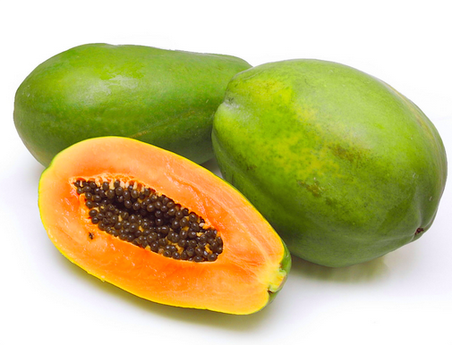

#### 9 Oranges:

Vitamin C is not the only reason to include citrus fruits in your diet. They rank the highest in folic acid content too. A medium sized orange provides the body with 29 micrograms of folic acid. Packaged orange juice also comes fortified with folic acid. A ¾ cup serving of orange juice contains 35 micrograms of folic acid.

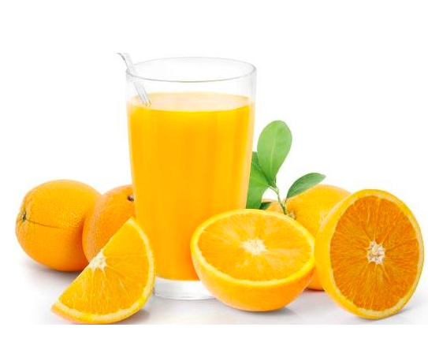

10. Beets and Cauliflower

Another vegetable despised by kids is the brussels sprout! It contains folic acid along with the benefits of vitamin A, C and K.

Although cauliflower is popular for containing large amounts of vitamin C, it also has plenty of folic acid packed inside. Eat one cup and you will get 55mcg of folic acid. Adding cauliflower to your daily diet is simple–just add some to your salad or a lunchtime curry.

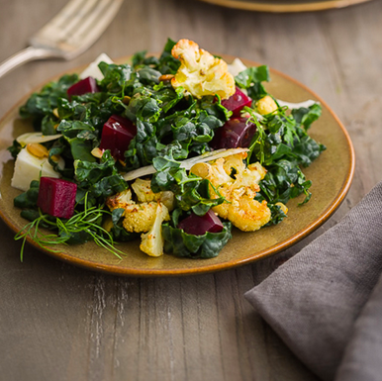

# Top 10 Foods rich in Vitamin C

Vitamin C is a water-soluble, antioxidant vitamin, also known as ascorbic acid. Vitamin C, helps in the absorption of iron, and maintain capillaries, bones, and teeth. Humans do not have the ability to make their own vitamin C. Therefore, we must obtain vitamin C through our diet.

Vitamin C is good for the immune defence system. It helps in the protection from bacteias and viruses. It helps in healing wounds.

**Vitamin C helps the body to:**

Vitamin C is an antioxidant vitamin needed for the formation of collagen to hold the cells together and for healthy teeth, gums and blood vessels; improves iron absorption and resistance to infection.

**Deficiency of this vitamin can cause:**

* Bleeding gums
* Anemia
* Decreased wound healing rate
* Dry, dull and damaged hair
* Easy bruising
* Inflammation of gums
* Nose bleeding
* Weight gain due to slow metabolism
* Rough, dry, dull and scaly skin
* Swollen and painful joints
* Weak tooth enamel.

**Below is a list rich in Vitamin C:**

### ****1. Green leafy vegetables:****

Green leafy vegetables like kale, spinach, mustard greens and turnip greens are rich in phytochemicals, carotenoids, antioxidants, vitamin A and C. These disease fighting plant chemicals team up with vitamins and minerals to fight cancer and other chronic diseases. One cup of chopped kale can help you meet more than the daily value. One cup of chopped mustard green provides 539 milligrams of vitamin with just 15 calories. One serving of raw turnip greens provides 33 milligrams of vitamin C. Green leafy vegetables also prevent the stroke, degeneration and osteoarthritis. So, toss your salad with these green to enjoy the nutritional benefits.

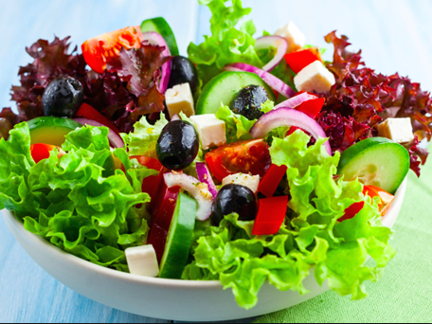

### ****2. Guavas:****

Guava is considered a super food owing to its high mineral and vitamin content. The fruit is abundant in vitamin C. A medium sized guava provides 125.57 milligrams of vitamin C. This equals to over 200% of the daily recommended value. This exotic fruit is high in fiber, which aids in the gastrointestinal health. It is also a good source of folic acid, manganese and potassium.

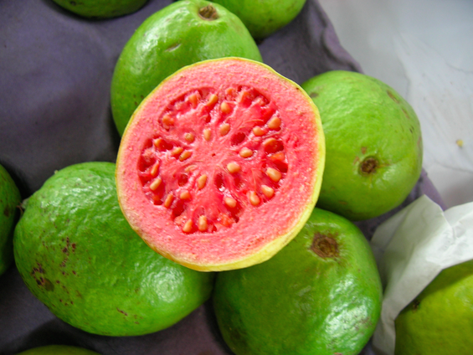

### ****3. Broccoli:****

Cooked or raw, you can never go wrong with broccoli. The high levels of antioxidants in broccoli help to boost the immune system, preventing the body from several diseases. A half cup of broccoli can provide you with 81.17 milligrams of vitamin C, enough to meet the daily value of vitamin C. This cruciferous vegetable is low in calories as well, a half cup containing just 30 calories. Now do you need any more reason to add this healthy vegetable in your diet?



**4. Bell Peppers (Yellow Bell Peppers):**

These sweet and colorful vegetables are one of the most nutrient dense foods you can include in your diet. These versatile vegetables add a great flavor to your pizza and pasta dishes while preventing heart diseases. A medium sized bell pepper provides 342 milligrams of vitamin C. This equals to 570% of the daily value. Bell peppers are also known to prevent cataract and blood clot formation. All bell peppers contain high levels of vitamin C, but yellow has the highest, followed by red pepper.

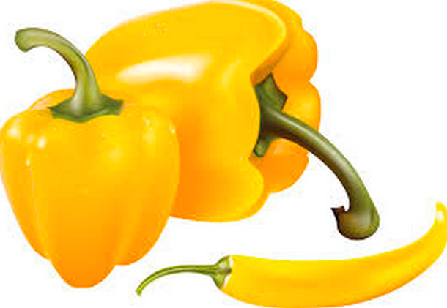

### ****5. Kiwi:****

The fuzzy, egg shaped fruit is a better source of vitamin C than orange. One kiwi fruit a day can provide your body with 85 milligrams of vitamin C. To preserve the vitamin C content in kiwi, eat the fruit uncooked. Enjoy kiwi fruit for your breakfast or as a hearty and filling smoothie.

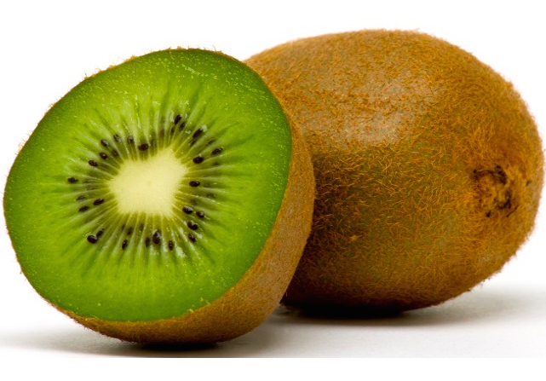

### ****6. Peas:****

Fresh and sweet garden peas are another excellent source of vitamin C. It contains plant based protein and non-heme iron, making it an excellent food for the vegetarians. Peas can also help to reduce the risk of developing certain cancers, depression, macular degeneration and high cholesterol. 100 grams peas provide 41 grams of vitamin C.

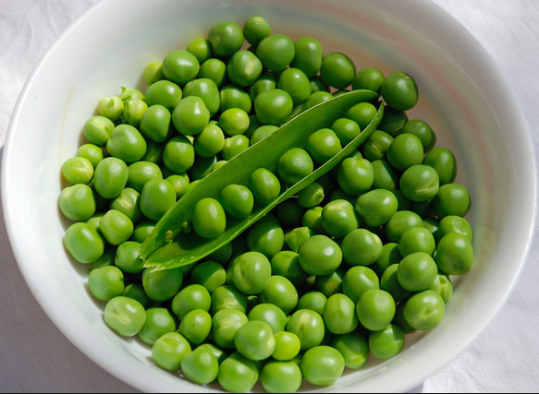

### ****7. Brussels sprouts:****

Brussels sprouts might not be a favorite of kids, but just one cup serving can provide 113% of the daily value of vitamin C of an average adult. Brussels sprouts are a great source of vitamin K, iron, folate, potassium and phosphorus also.

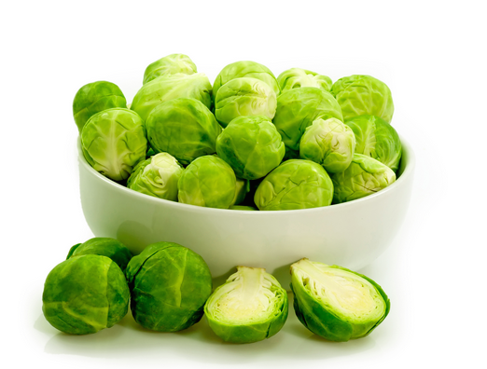

### ****8. Citrus fruits:****

Citrus fruits like orange, lemon and grapefruit are the most common sources of vitamin C. Both juice and fresh fruit can help you much of the daily value of vitamin C. A half cup of grapefruit juice provides 70 milligrams of vitamin C, while orange juice provides 93 milligrams. Citrus fruits are a great source of folic acid, B complex vitamins and potassium. A single orange provides 70 milligrams and a medium sized grapefruit provides 65 milligrams of vitamin C.

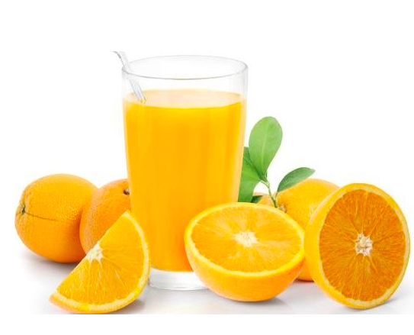

### ****9. Strawberries:****

Strawberries are nutritional powerhouses. They burst with healthy compounds, phytochemicals and nutrients like fiber, folate and magnesium. The high levels of antioxidants in berries reduce the oxidative stress, protecting the heart from low-density lipoprotein cholesterol. Berries make an excellent addition to your smoothies, fruit salad and a healthy treat after dinner. Just serving of strawberries can help you meet your daily vitamin C need. 100 grams of this delicious berry provide 98 milligrams of vitamin C and just 53 calories.

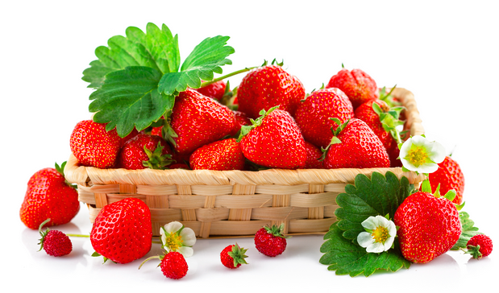

### ****10. Papaya:****

Papaya is another excellent source of vitamin C. One medium papaya fruit provides 187.87 milligrams of vitamin C. This is three times more than the daily recommended amount. This delicious and colorful fruit provides the body with other health benefits as well. It contains nutrients like vitamin A, B, K, calcium and potassium. Throw a slice of papaya to your smoothie or yogurt for a delicious, power packed treat.



# Top 10 Foods rich in Vitamin D

A deficiency in vitamin D can lead to serious health problems. Improper levels of vitamin D can make the bones soft and brittle, leading to osteoporosis. In children, vitamin D deficiency can cause rickets, a disease that causes the bones to soften, leading to fracture and deformity. Inadequate levels of vitamin D can also lead to other chronic health conditions like diabetes, high blood pressure, arthritis and even cancer in extreme cases. Conversely, excess vitamin D can cause the body to absorb high concentrations of calcium, leading to risk of heart attack and kidney stones.

**Vitamin D helps the body to:**

Vitamin D helps the body absorb [calcium](http://health.nytimes.com/health/guides/nutrition/calcium-in-diet/overview.html). Calcium and phosphate are two minerals that are essential for normal bone formation.

Throughout childhood, your body uses these minerals to produce bones. If you do not get enough calcium, or if your body does not absorb enough calcium from your diet, bone production and bone tissues may suffer.

Vitamin D deficiency can lead to [osteoporosis](http://health.nytimes.com/health/guides/disease/osteoporosis/overview.html) in adults or [rickets](http://health.nytimes.com/health/guides/disease/rickets/overview.html) in children.

**Deficiency of this vitamin can cause:**

* Pregnant and breastfeeding women, especially teenagers and young women.
* Infants and children under 5 years of age.
* 65 year olds and over.
* People who have little or no exposure to the sun. This includes covering-up for cultural reasons, people who are housebound or who stay indoors for long periods of time.
* People with darker skin, such as African, African-Caribbean and South Asian origin. These groups are not able to make as much vitamin D as those with paler skin.

**Below is a list rich in Vitamin D:**

### 1 Tofu:

Soy products like tofu and tempeh are foods rich in calcium and vitamin D. Make sure you check the nutritional label before purchasing the soy products. A 100-gram serving of fortified tofu can provide you with 39% of the daily value of vitamin D. Tofu is high in protein too.

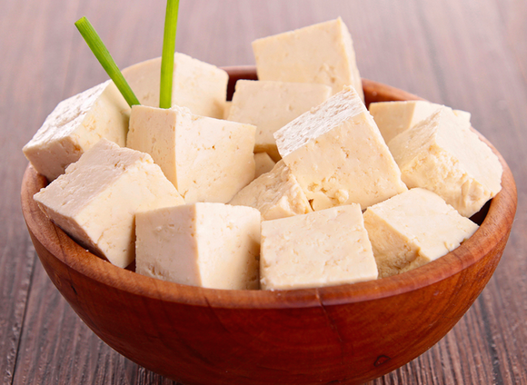

### 2 Salmon Fishes:

Fish with high oil content like herring, mackerel, salmon and tuna are excellent sources of vitamin D. A single fillet of herring provides 306 IU of vitamin D, nearly half the daily value for an adult. A 100 grams of canned salmon provides 91% of the daily recommended value of vitamin D. Mackerel fish is also a reliable source of vitamin D. This cold-water fish can be enjoyed both canned and raw. Besides providing vitamin D, oily fishes can also help you obtain nutrients like calcium, protein and phosphorus.

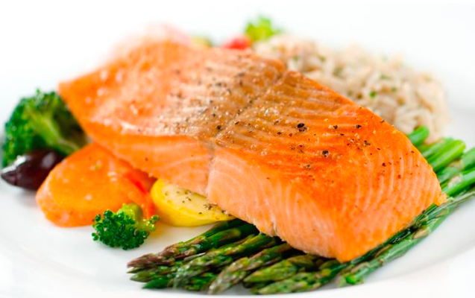

### 3 Mushrooms:

Mushrooms are one of the most viable sources of vitamin D. They are another rich vitamin D foods. Mushroom is exposed to the sun’s ultraviolet rays while growing, which increases its vitamin D value. The amount of vitamin D varies according to its type and varieties. White mushrooms, better known as button mushrooms are an excellent source of vitamin D. 4 shiitake mushrooms provide a modest 3% of the daily value of vitamin D and 140 calories. A cup of diced mushroom provides a hearty 64% of the daily value of vitamin D, while being extremely low in calories. Mushrooms also provide several other health benefits.

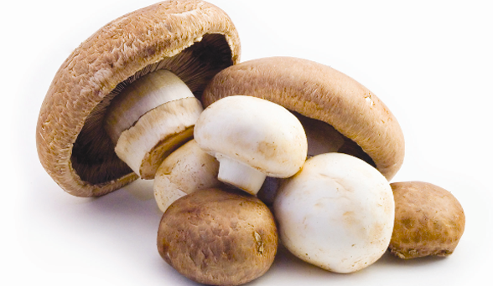

### 4 Cod liver oil:

Cod liver oil is one of the easiest ways to get your daily dose of vitamin D. It is more of a supplement than food. Cod liver oil is obtained from the liver of the codfish. It is usually available in the form of capsules. 1 teaspoon of cod liver oil will provide you with 450 IU of vitamin D and 41 calories. This golden oil is also rich in omega 3 fatty acids that can help promote bone health and fight osteoporosis in adults.

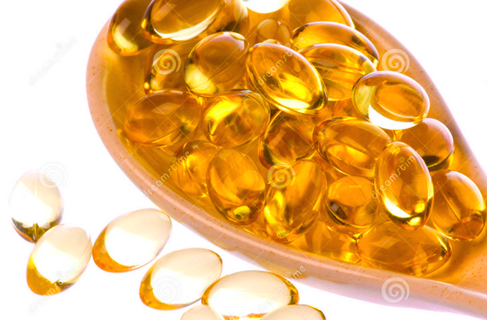

5 **Dairy Alternatives (Plain Soy Yogurt)**:

Dairy products like cottage cheese, cheese and yogurt are often fortified with vitamin D to increase the calcium absorption. Yogurt is one of the best foods to stay young and healthy. A cup of fortified yogurt can help you meet 20% of the daily value of vitamin D.

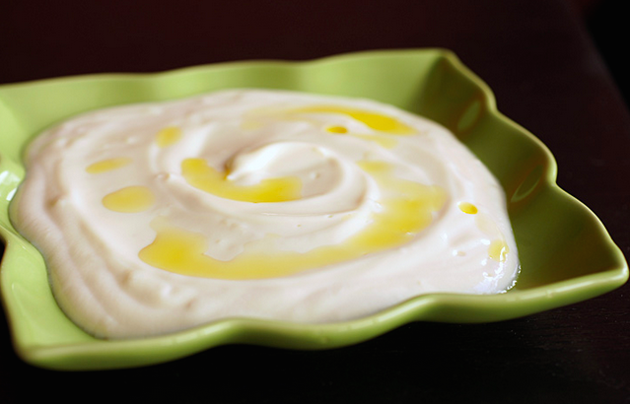

 6 Cereals:

In addition to milk, cereals are also fortified with essential nutrients including vitamin D. The brands and types of cereal vary widely, so check the label for proper information. One cup of fortified cereals can provide you with up to 30% of the daily recommended value of vitamin D.

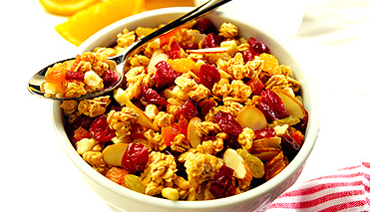

### 7 Cheese:

Cheese is a good source of Vitamin D. Vitamin C and D are required to make you feel healthy and look younger. Cheese comes in several varieties and is widely used in sandwiches, pizzas and other recipes. Being a dairy product, it is considered quite nutritious. Among the cheese varieties, Gjetost is the best source of vitamin B5 providing 3.35 mg or 34% DV in a 100 grams serving. Other varieties of cheese that contain vitamin B5 in smaller amounts include Roquefort and blue cheese (5% DV), camembert (4% DV) and feta (3% DV) in an ounce serving.

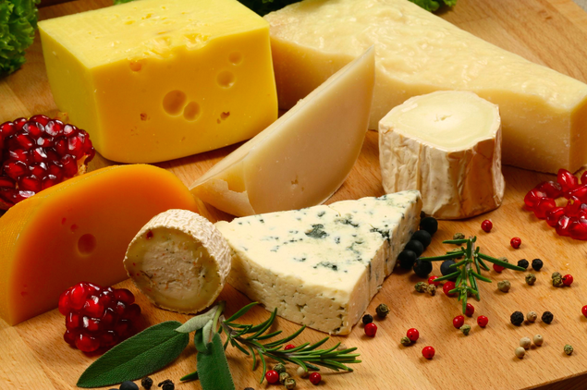

### 8 Eggs:

The wide variety of nutrients found in the eggs can help promote healthy hair, nails and body. A whole, large egg can provide you with 7% of the daily-recommended value of vitamin D. The yolk of the egg can help you get 6% of the daily value of vitamin D. Egg yolk also provides nutrients like Vitamin A, E, K, D, iron and zinc. Besides, eggs also contain protein, sulfur, essential amino acids and choline.

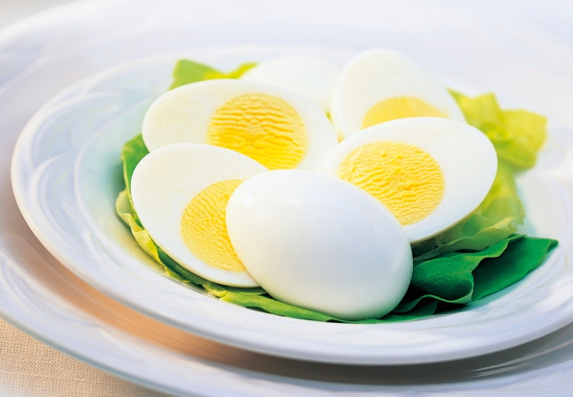

9 Caviar:

Fish eggs can also play an important part in a healthy and balanced diet. One serving of caviar egg provides 19 UI of vitamin D. Caviar also contains a chock full of immune boosting nutrients like vitamins, minerals and essential fats.

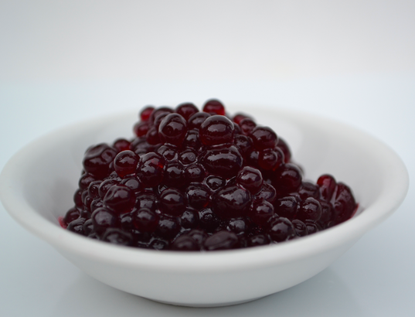

### 10 Whole milk:

Most of the packaged milk is fortified with vitamin D these days. You need to drink high amounts of fortified whole milk to stay healthy and fit. A cup of fortified milk will provide 21% of the daily vitamin D value.

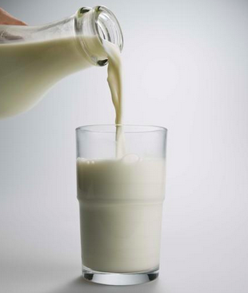

## ****Top 10 foods rich in Vitamin A:****

Vitamin A is an essential vitamin required for vision, gene transcription, **boosting immune function**, and great skin health. A deficiency in vitamin A can lead to blindness and increased viral infection, however deficiency is only considered a problem in developing countries where it is a leading cause of blindness in children. Overconsumption of vitamin A can lead to jaundice, nausea, loss of appetite, irritability, vomiting, and even hair loss. Vitamin A is a fat soluble vitamin, and therefore, needs to be consumed with fat in order to have optimal absorption. High vitamin A foods include sweet potatoes, carrots, dark leafy greens, winter squashes, lettuce, dried apricots, cantaloupe, bell peppers, fish, liver, and tropical fruits. The current daily value for Vitamin A is 5000 international units (IU).

**Vitamin A helps the body to:**

* the process of vision (especially night vision)
* growth and development – it is involved in the genetic regulation of cell and tissue formation, programming, and communication needed for reproduction and for the proper development of the embryo in the womb
* immune function – it helps to protect against infections by ensuring the effectiveness of mechanical barriers (e.g., skin), and increasing the production and efficacy of protective cells (e.g., lymphocytes)
* male and female reproductive organs.

**Deficiency of this vitamin can cause:**

Vitamin A deficiency usually results from inadequate intake of foods high in vitamin A or [beta-carotene](http://www.nutri-facts.org/eng/carotenoids/beta-carotene/at-a-glance/" \t "_top), a precursor of vitamin A. The earliest symptom of vitamin A deficiency is night blindness. Groups at risk for insufficient vitamin A supply are mainly pregnant and breast-feeding women, newborns, children with frequent infections, the elderly and people who avoid animal-derived foods.

**Below is the list rich in Vitamin A:**

### ****1. Carrots:****

When most people think of Vitamin A and eye health, they think of carrots. It’s true that eating plenty of carrots can improve your vision. One medium carrot accounts for over 200% of the average person’s Vitamin A needs for the day. They’re also a great source of Vitamins C, K, and B, plus magnesium and fiber. **Serving Size (1 medium), 10191 IU of Vitamin A (204% DV), 25 calories.**

### 

### ****2. Sweet Potato:****

Sweet potatoes were one of the main sources of food for early American settlers. Today, they’re still widely enjoyed for their delightful taste and rich nutrient contents. One medium sweet potato provides an incredible 438% of the average adult’s Vitamin A needs for the day, all while adding only 103 calories to your diet.

**Serving Size (1 medium), 21909 IU of Vitamin A (438% DV), 103 calories.**



### ****3. Dark Green Leafy Vegetables:****

The Dark Green leafy vegetables is filled with essential Vitamin A. Don’t be afraid to add some to your salad and sandwiches when you need an extra boost of Vitamin A. One cup of leafy vegetables contains only 10 calories, and it brings a heap of other vitamins and minerals to your body.

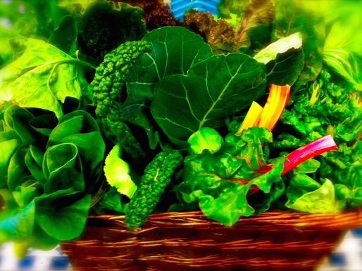

### ****4. Squash:****

Raw or cooked, squash is an extremely flavorful and nutritious food. The vegetable is high in beta-carotene, which is converted to vitamin A in the body. A half cup of canned pumpkin provides 953 milligrams of vitamin A and just 42 calories. 100 grams of cooked butternut squash provide 11155 UI of the daily value of vitamin A. Other squashes rich in vitamin A are Hubbard and pumpkin. Squash is also a good source of vitamin C, manganese, magnesium and fiber.

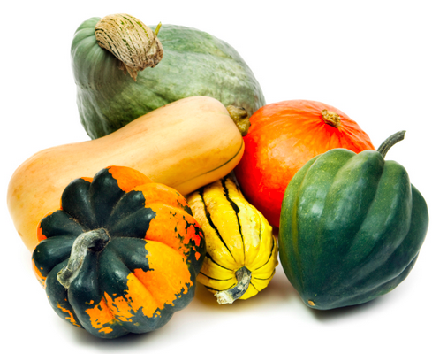

### ****5. Lettuce:****

The lighter green Iceberg lettuce variety is filled with essential Vitamin A. Don’t be afraid to add some to your salad and sandwiches when you need an extra boost of Vitamin A. One cup of shredded Iceberg lettuce contains only 10 calories, and it brings a heap of other vitamins and minerals to your body.

**Serving Size (1 cup shredded), 361 IU of Vitamin A (7% DV), 10 calories.**

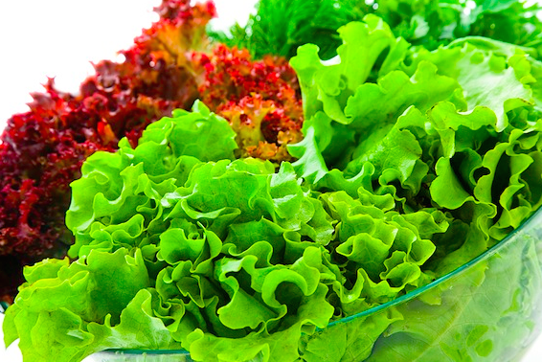

### ****6. Dried Fruits:****

Dried fruits are healthy on-the-go snacking option. Dried fruits like prunes, apricots and peaches are a great source of vitamin A. Apricot contains the highest levels of vitamin A out of all the dried fruits. A 100 grams serving provides 12669 IU of vitamin A, more than 200% of the daily-recommended value. Prunes provide 24%, while dried peaches provide 17% of the daily value of vitamin A. Dried fruits can help boost the energy, antioxidants and nutrient levels as well.

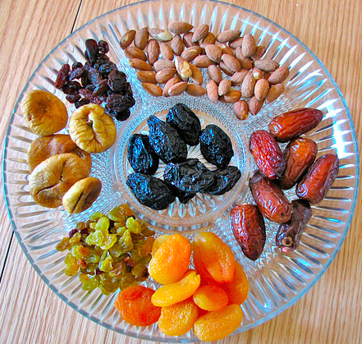

### ****7. Cantaloupe Melon:****

Cantaloupe is low in calories and fat, but high in vitamins and nutrients. It’s also a delicious addition to your day. Enjoy this succulent melon in a fruit salad, as a midday snack, or as an after-dinner dessert. One wedge, or about an eighth of an average-sized melon, provides you with 120% of the amount of Vitamin A for the day.

**Serving Size (1 wedge, or 1/8 medium melon), 5986 IU of Vitamin A (120% DV), 23 calories.**

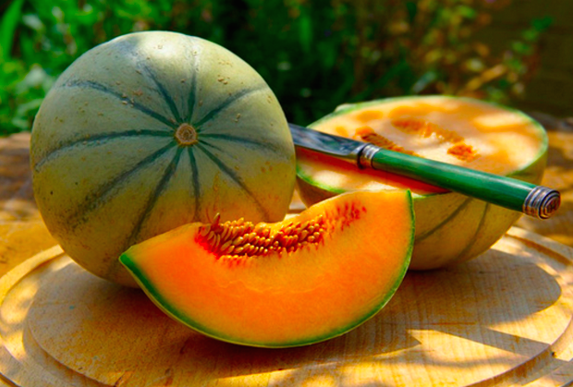

**8. Sweet Red Peppers:**

Bell pepper is another excellent source of vitamin A. 1 cup chopped red bell peppers can contribute 4665 IU of vitamin A, almost 100% of the daily-recommended value. Green bell peppers provide 12 % and yellow bell peppers can help you meet 7% of the daily value of vitamin A. Bell peppers are also rich in antioxidant like lycopene, phytochemicals, vitamin C and calcium. So, add a few slices of bell pepper to your dishes to enhance its nutritional value and taste. This versatile vegetable can be enjoyed in salads, eggs, and pizza and pasta dishes. You can even eat it plain or with a vegetable and cream dip.

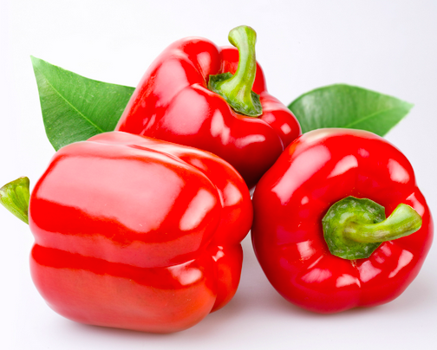

**9. Tuna Fish (Bluefin):**

Seafood like tuna, oyster, salmon, sturgeon and mackerel are some good sources of vitamin A in animal-based foods. One 100 grams tuna fillet can help you meet 50% of the daily value. Sturgeon and mackerel provide 15% of the daily-recommended value of vitamin A. Oyster is another nutritional powerhouse. An ounce serving of oyster can provide 8% of the daily value of vitamin A. Sea food is also rich in omega 3 fatty acids that play a vital role in retinal health and reduce the risk of macular degeneration. It is also rich in niacin, which can help to reduce the risk of cataracts. Aim to eat at least two servings of seafood every week.



### ****10. Mango and Papaya:****

Mango is a sweet and juicy fruit that finds its place in both main dishes and dessert plate. This delicious tropical fruit is a storehouse of several important nutrients and can form an important addition to a healthy and balanced diet. A medium sized mango provides 3636 IU of vitamin A, equaling to 73% of the daily value.

Papaya is another tropical fruit containing moderate amounts of vitamin A. A small papaya contributes 30% of the daily value of vitamin A. Papaya is also high in several vitamins, minerals, enzymes and antioxidants. This tasty fruit will make a great addition to your fruit salads and smoothies.

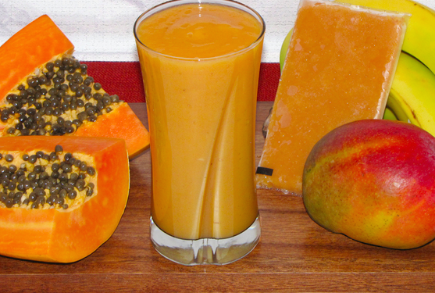

# Top 10 Foods rich in Vitamin B12 (Cobalamin)

Vitamin B-12, or Cobalamin, is the largest and most complex vitamin currently known to man. A slight deficiency of vitamin B-12 can lead to anemia, fatigue, mania, and depression, while a long term deficiency can potentially cause permanent damage to the brain and central nervous system. Vitamin B-12 can only be manufactured by bacteria and can only be found naturally in animal products, however, synthetic forms are widely available and added to many foods like cereals. Vitamin B-12 can be consumed in large doses because excess is excreted by the body or stored in the liver for use when supplies are scarce. Stores of B-12 can last for up to a year. Below is a list of the top ten vitamin b12 rich foods.

**Vitamin B12 helps the body to:**

* The formation of red blood cells
* Cell division
* Nerve structure and function
* The maintenance of normal blood homocysteine levels, together with folate and vitamin B6 (raised levels are a risk factor in cardiovascular disease).

**Deficiency of this vitamin can cause:**

* Fatigue
* Constipation
* Depression
* Low Sperm Count and Libido
* Weakness and Anemia
* Asthma

**Below is the list rich in Vitamin B12:**

### 1. ShellFishes:

Shellfish are a great source of vitamin B12 and can be eaten raw, baked, steamed, fried, or made into chowder. In addition to vitamin B12 shellfish are a good source of zinc, copper, and iron. Clams provide the most vitamin B-12 with 98.9μg per 100g serving, accounting for 1648% of the RDA. That is 84μg (1401% RDA) per 3 ounce serving, and 187.9μg (3132% RDA) in 20 small clams, or 9.4μg (156.6 %RDA) in one small clam. Mussels and oysters are also good sources of B12 providing 600% RDA and 400% RDA per 100 gram serving.

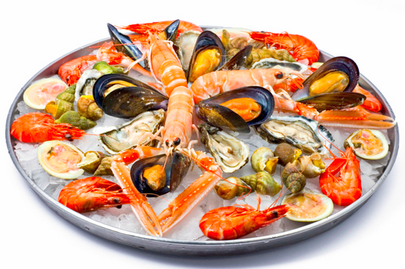

2. **Fish (Mackerel)**:

Fish Known for their omega 3 fats and for being a high protein food, fish are also a good source of vitamin B12. Mackerel provides the most vitamin B-12 with 19μg per 100g serving (317% RDA), followed by Herring (312% RDA), Salmon (302% RDA), Tuna (181% RDA), Cod (167% RDA), Sardines (149% RDA), Trout (130% RDA), and Bluefish (104% RDA).

.

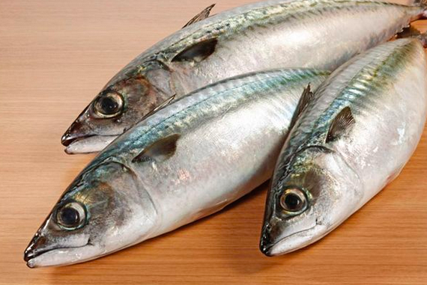

### 3. Eggs:

When it comes to chicken eggs the raw yellow has most of the vitamin B-12 with 1.95μg per 100g serving (33%), however, this equates to 0.33μg per yolk or just 6% of the RDA. The eggs of other animals are higher with a goose egg providing 7.34μg (122% RDA) of vitamin B-12 per 100g serving, and a duck egg providing 3.78μg (63% RDA).

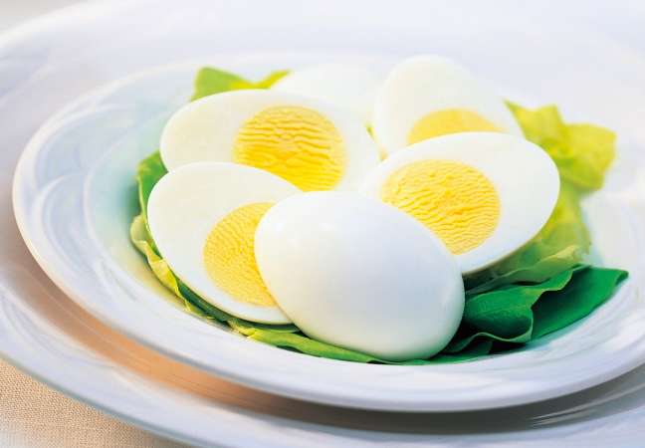

### 4. Oyster:

Oyster is another excellent source of vitamin B12. A 3-ounce serving of oyster provides nearly 30 micrograms of vitamin B12. This equals to a whopping 500% of the daily-recommended value of vitamin B12. Oyster is also an excellent source of vitamin A, riboflavin, thiamine, vitamin C and D. Wild oysters have a high amount of contaminants and should be harvested using destructive methods.

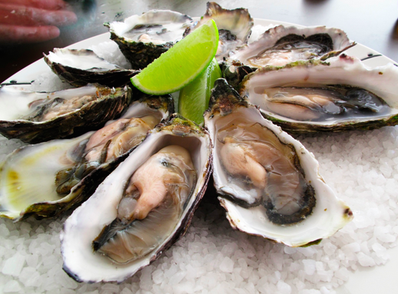

### 5. Crab:

Crab and lobster are most commonly served baked, steamed, or in bisque. A 100g serving of crab contains 11.5μg of vitamin B12 (192% of the RDA), that is 15.4μg (257%RDA) per leg (134g). Lobster will provide 4.04μg(67% RDA) per 100g serving, or 6.59μg (110% RDA) in an average whole lobster (163g).

.

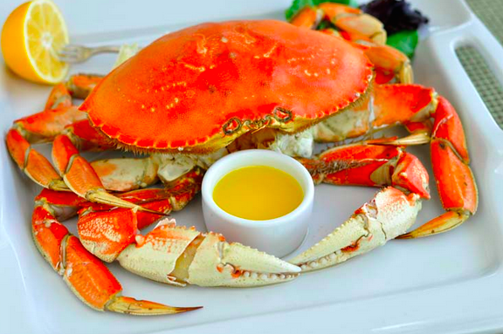

### 6. Cereals:

Cereals are a healthy way to start the day. Fortified cereals have around 6 micrograms of vitamin B12 per cup. Do not forget to check the label before purchasing the cereals as the nutritional value varies according to the brand. Choose whole grain cereals and avoid adding extra sugar to it.

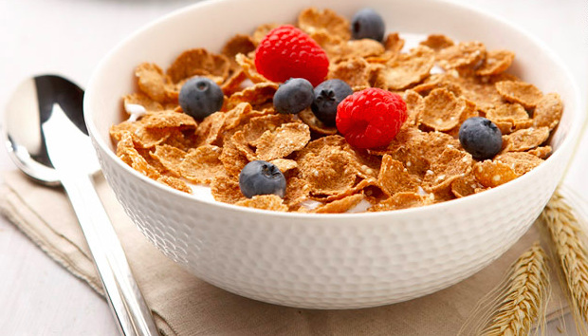

### 7. Poultry:

Poultry like turkey and chicken are healthier alternatives to red meat. Both chicken and turkey are good sources of several essential vitamins and minerals and are free from fat and calories. A 100 grams serving of chicken provides 7 % of the daily-recommended amount of vitamin B12. Poultry is a good source of protein, selenium and vitamin B3.



8. **Low Fat Dairy (Skim Milk)**:

The nutritive value of milk is not just limited to calcium and Vitamin D. It is an amazing source of vitamin B12 as well. One cup of whole milk contains more than one microgram of vitamin B12, amounting to 18% of the daily-recommended value. Eat fortified cereals with milk to get your proper dosage of vitamin B12. Not just whole milk, yogurt can also provide you with vitamin B12. A quarter cup of yogurt provides 1.49 micrograms of vitamin B12.

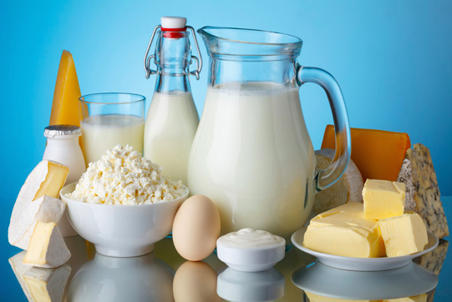

Soymilk is a healthier alternative to whole milk. Even people intolerant to lactose can enjoy it. Fortified soymilk can help you meet 19% of the daily-recommended amount of vitamin B12, while being low in calories. It is also high in vitamins A and D.

### 9. Fortified Tofu:

Fortified tofu is a rich way to supplement your diet with several essential nutrients. It is a good source of protein, calcium, phosphorus and vitamin D. A quarter serving of fortified tofu provides 1.86 grams of vitamin B12. This equals to 31% of the daily-recommended value.

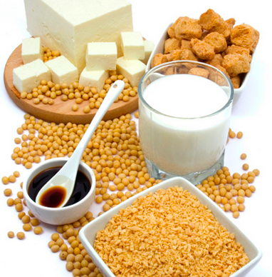

### 10. Liver(Beef):

Often appearing on the culinary scene as pâté, liver can also be prepared steamed or fried with onions and herbs. The liver of most any animal is packed with vitamin B-12, the highest on the list are: Lamb, beef, veal, moose, turkey, duck, and goose respectively. Lamb liver provides 85.7μg (1428% RDA) of vitamin B12 per 100g serving, or 72.85μg (230% RDA) in a 3 ounce serving.



## Top 10 Foods Rich in Vitamin K:

Vitamin K is a fat soluble vitamin responsible for proper functioning of several bodily systems. The foremost function of this substance is to assist blood clotting process. Moreover, it also helps building and strengthening bones and in preventing kidney stones. Researchers are also looking into the role of vitamin K in treating osteoporosis and Alzheimer’s as well as preventing cancer and cardiovascular disorders.

Deficiency of vitamin K can increase the risk of uncontrolled bleeding. Vitamin K deficiency is rare in adults and very common in newborn infants. Pediatricians usually advise vitamin K injections for infants. You can get adequate amounts of vitamin K from your diet. In fact the best way to get the recommended amount of vitamin K is to increase the consumption of vitamin K rich foods. Given below are good sources of vitamin K and can form a part of your diet.

**Vitamin B12 helps the body to:**

**Deficiency of this vitamin can cause:**

The deficiency of vitamin K can be extremely detrimental for human health and so can be its overdose. Lack of K vitamin in an individual increase the odds of haemorrhage (bleeding), osteoporosis, bone fracture and easy bruising. In severe cases, vitamin K deficiency can also chock the patient to death.

Its overdose, conversely, can bring about vitamin-K-toxicity in the body. Excessive consumption of vitamin K can also cause the blood to thicken and hence can trigger stroke or vascular problems. So, one should always go easy on the consumption of vitamin K so as to avoid both extreme conditions – deficiency or overdose.

**Below is the list rich in Vitamin K:**

### 1. Dried Herbs and Spices:

Long employed to serve medical purposes, herbs are naturally packed with various vital nutrients including vitamin K which makes it a good option among the vitamin k sources. Dried basil, sage, thyme, coriander, marjoram, oregano and parsley are considerable options to incorporate in routine diet for increasing your vitamin E intake.

Hosting a significant content of vitamin C and E, red chilli powder is a great addition to spice-up a cuisine and get your daily vitamin K needs. Curry powder, paprika and cayenne also contain decent amounts of vitamin K. Try adding these spices in your regular soups and salads.

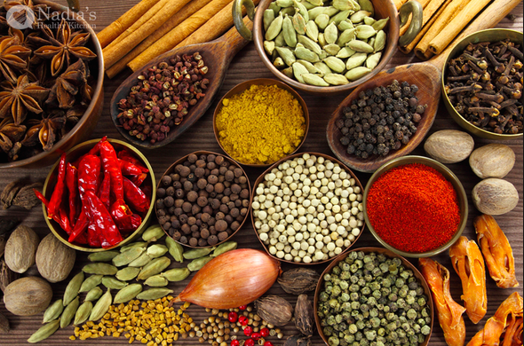

### 2. Dark Green Leafy Vegetables (Kale):

Dark green leafy veggies are exceptionally rich in vitamin K as well as calcium. Kale is the richest source providing a whopping 882 µg or 1103% DV in a 100 grams serving. Dandelion greens come second with 100 grams serving, contributing 535% DV of vitamin K. Other leafy greens include collards, broccoli, cress, turnip greens, spinach, beet greens, Swiss chard, radicchio, mustard greens and lettuce each providing 62.5 µg or 78% DV in a cup serving. You can have these delicious and crispy leafy greens in a salad or a recipe of steamed vegetables to boost your vitamin K levels.

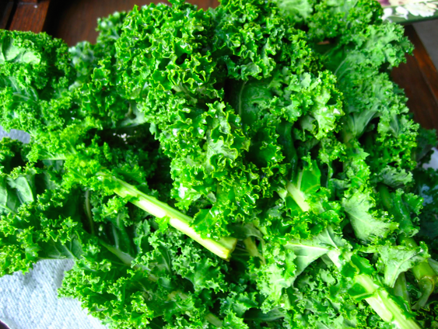

### 3. Brussels Sprouts:

This delicious veggie is packed with nutrition and vitamin K is no exception. A single Brussels sprouts provides you with 33.6 µg or 42% DV of vitamin K while a 100 grams serving provides you with 194 µg or 242% DV of this vitamin. They are also high in selenium which can reduce the risk of certain types of cancers. They are good for your digestive system and possess cholesterol lowering properties. Having Brussels sprout in your diet is a great way to boost your levels of vitamin K as well as other nutrients like vitamins A and C, iron, magnesium, copper, phosphorus, potassium, folate, manganese and dietary fiber. So why not have steamed Brussels sprout as a side dish to your meals!

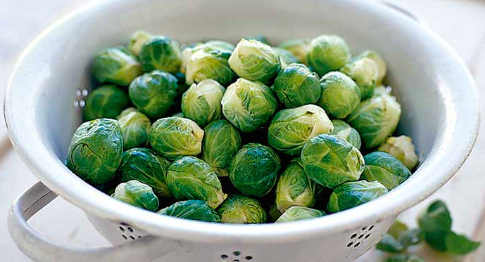

### 4. Broccoli:

This green vegetable from the cabbage family is one of the most nutrient dense foods known so far. It is also low in calories. Its rich variety of nutrients include vitamin K as well. It provides 141 µg or 176% DV of vitamin K in a 100 grams serving and 52 µg or 65% DV of vitamin K in a single piece. It provides various health benefits like boosting the immune system, cardiovascular health, cancer prevention, bone health and prevention of birth defects. You can have steamed broccoli or broccoli soup to reap these amazing health benefits.

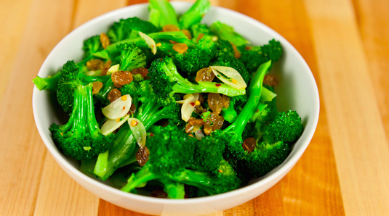

### 5. Spring Onions:

Spring onions or scallions are also a good source of vitamin K, providing 207 µg or 259% DV of vitamin K in a 100 grams serving. They are also abundant in B-complex vitamins like pyridoxine, folic acid, riboflavin, niacin and thiamine as well as minerals like manganese, calcium, copper and iron. You can incorporate them in your diet in soups or stews or use them in salads and wraps.

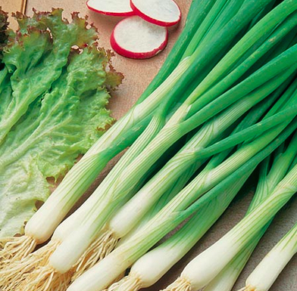

### 6. Cabbage:

Raw or steamed cabbage can help treat high cholesterol, stomach ulcers, arthritis, weight gain, and constipation. A cup of chopped cabbage contains 76 micrograms of Vitamin K, or nearly 100% of the total daily value. Eat more cabbage to improve your intake of Vitamin K as well as Vitamin C, fiber, Vitamin E, calcium, magnesium, and potassium. **Serving Size (1 cup chopped), 76 micrograms of Vitamin K (95% DV), 22 calories**

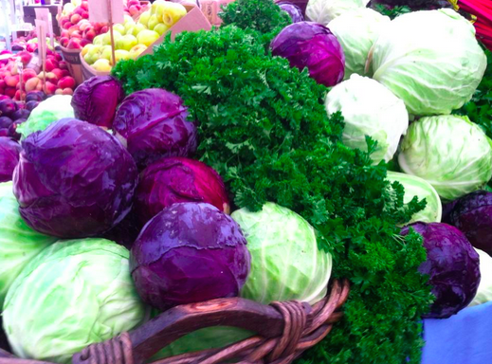

### 7. Asparagus:

There are many reasons to love asparagus. It has anti-aging properties, it may help prevent Alzheimer’s disease, and it’s packed with antioxidants to protect against free radicals and certain cancers. It’s also loaded with many of the vitamins and minerals your body needs to stay healthy and in top working order. These include Vitamin A, Vitamin C, folate, fiber,[Vitamin E](http://bembu.com/vitamin-e-foods), and Vitamin K. **Serving Size (4 spears), 48 micrograms of Vitamin K (60% DV), 11 calories**



### 8.Celery:

Celery is a flavorful vegetable that’s easy to prepare when you’re in the mood for a healthy snack. One medium stalk of celery provides 15% of the recommended intake of Vitamin K, and it’s also a great source of folic acid, antioxidants, calcium, and potassium. And at only 6 calories per stalk, you can enjoy it in abundance without having to worry about your waistline. **Serving Size (1 medium stalk), 11.72 micrograms of Vitamin K (15% DV), 6 calories**

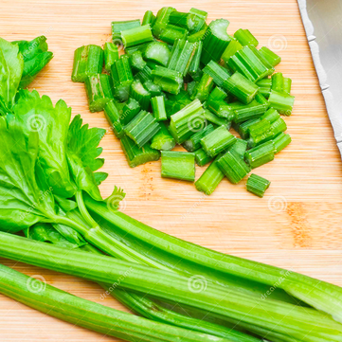

### 9. Pickled Cucumber:

Pickles contain minute amounts of a number of vitamins and minerals. For Vitamin K, however, they’re a surprisingly healthy choice. One medium pickle contains 34% of the daily recommended value. Pickles are also a good source of fiber, and contain a small but nonetheless helpful supply of antioxidants such as Vitamin A and lutein. **Serving Size (1 medium), 26.85 micrograms of Vitamin K (34% DV), 43 calories**

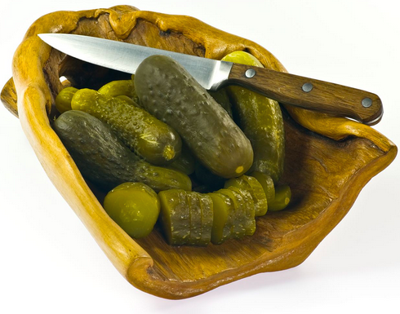

### 10.Carrots:

One medium carrot provides over eight micrograms of Vitamin K, enough to help you reach 10% of the daily recommended value. That same carrot adds only 25 calories to your diet, and the abundance of other vitamins and minerals makes carrots a great food to enjoy on a regular basis. **Serving Size (1 medium), 8.05 micrograms of Vitamin K (10% DV), 25 calories**

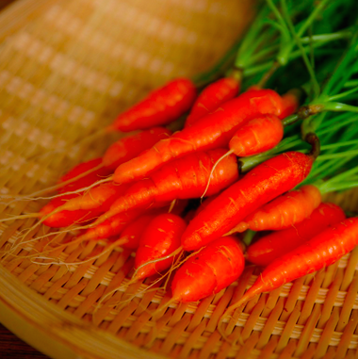

# Top 10 Foods rich in Vitamin E

Vitamin E is an important fat-soluble antioxidant compound that aids the body in neutralizing the harmful after-effects of oxidation of fats. Current research is even looking into the important role that this vitamin plays in stopping free-radical production, a key method of preventing the development of chronic diseases and ageing. It is also a vital element in the overall maintenance of a healthy immune system.

**Vitamin B12 helps the body to:**

* It helps to maintain the circulatory system, improve healing ability and decrease the premenstrual syndrome in women.
* Vitamin E is also required for maintaining a healthy and youthful skin and also to maintain over all system.
* It is also involved in the cell signaling, regulation of gene expression and other metabolic activities.
* Adequate amounts of vitamin E protect the body from cancer, heart diseases and age related macular degeneration.

**Deficiency of this vitamin can cause:**

* Peripheral neuropathy
* Ataxia
* Retinopathy
* Anemia
* Impaired immune response
* Skeletal myopathy
* Poor transmission of nerve impulses
* Muscle weakness
* Night blindness
* Nerve damage
* Inability to walk
* Reproduction related disorders

**Below is the list rich in Vitamin E:**

**1. Green Leafy Vegetables:**

The green leafy vegetables are not just used for garnishing the salads, but are extremely nutritious as well. Green leafy vegetables like spinach, Swiss chard, collard, turnip greens and kale are some of the best sources of vitamin E. 100 grams serving of spinach can help you meet 10% of the daily value of vitamin E. Swiss chard provides 16% and turnip greens provide 13% of the daily value. Kale and collard are moderate sources of vitamin E and contribute 8% and 5% of the daily value respectively. One serving of mustard greens provides 1.13 milligrams of vitamin E. Besides vitamin E, green leafy vegetables are excellent sources of antioxidant and vitamin A as well.



**2. Nuts:**

Nuts make a quick and healthy on-the-go snack. Nuts like almonds, hazelnuts, pine nuts, pistachio, walnuts and pecans are renowned sources of vitamin E. Almonds are the richest source of vitamin E, with 1 cup serving providing 37.5 milligrams of this essential nutrient. Hazelnut ranks second with a per ounce serving providing 21% of the daily value. Pistachio, pecan and walnuts provide 2% of the daily value of vitamin E. Peanut butter is also a good source of vitamin E, with 2 tablespoons of it providing 2.5 milligrams of vitamin E. Nuts also contain protein, vitamin A, calcium and phosphorus. The nuts will be a great addition to your salads and pasta dishes. However, nuts are high in calories, so enjoy them in moderation.

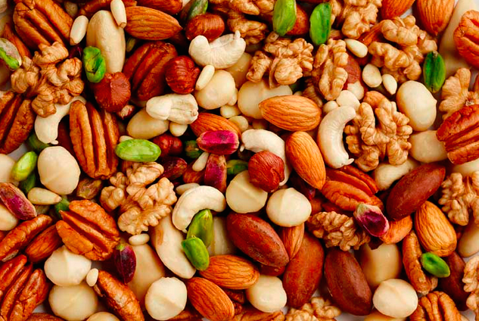

**3. Tofu:**

Tofu is a vegetarian food created by curdling soymilk. It comes in a variety of textures like soft and silken. Tofu is one of the amazing sources of vitamin E. 100 grams of tofu provides 5.3 milligrams of vitamin E, around 25% of the daily value. This creamy textured food is extremely versatile and can be used in various savory and sweet dishes.

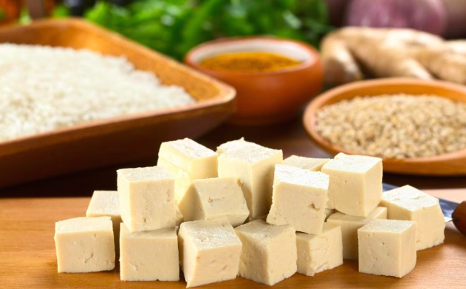

**4. Avocados:**

Avocado is one of the tastiest sources of vitamin E. A 100 grams serving of this tasty and creamy fruit contributes 4.1 milligrams of vitamin E and 250 calories. It is also high in B complex vitamins, vitamin C, K and several essential minerals. Avocados are extremely versatile. Add a slice of avocado to your salad or sandwich or mash it to prepare a delicious dip. Alternatively, apply mashed avocado paste to your skin to make it fresh and glowing.



**5. Sunflower Seeds:**

Sunflower is the good source of vitamin E along with that [pumpkin](http://www.globalhealingcenter.com/natural-health/vitamin-e-foods/) and sesame, are another common food with vitamin E. In fact, eating just ¼ of a cup of sunflower seeds gives you 90.5% of your recommended daily value, making them one of the best vitamin E foods you can eat daily.



**6. Broccoli:**

For generations now, broccoli has been considered one of the [best detox foods](http://www.globalhealingcenter.com/natural-health/foods-that-detox-the-body/), but it’s also one of the healthiest foods high in Vitamin E. Just one cup of steamed broccoli will provide you with 4% of your daily requirements. Broccoli may not be as nutrient dense as other Vitamin E foods on this list, but it is definitely one of the healthiest foods you can eat daily.



**7. Shrimp:**

Seafood like shellfish, oysters and fishes are good sources of vitamin E. 100 grams of shrimp provide 11% of the daily value of vitamin E. Oysters, on the other hand, provide 7% of the daily value of vitamin E. Rainbow trout is the best source of vitamin E out of all the fishes. Swordfish contains 10% and herring and smoked salmon provide 6% of your daily need of vitamin E.

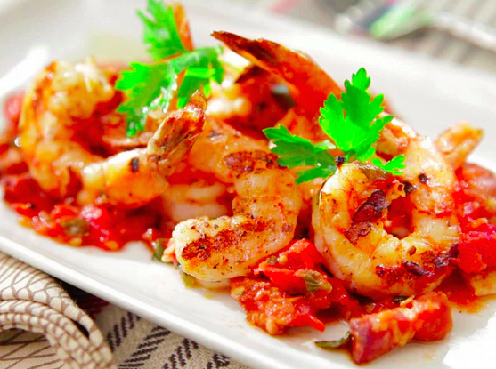

**8. Kiwi:**

When it comes to your skin, it doesn’t get much better than avocados. In fact, some people skip the snack and put the creamy mashed avocado right on their faces for silky smooth skin. If you actually eat the avocado instead, you’ll get all the benefits of the Vitamin E and more. Avocados are also high in B vitamins, Vitamin K, Vitamin C, and several minerals.**Serving Size (1 avocado), 4.16 milligrams of Vitamin E (20% DV), 322 calories**

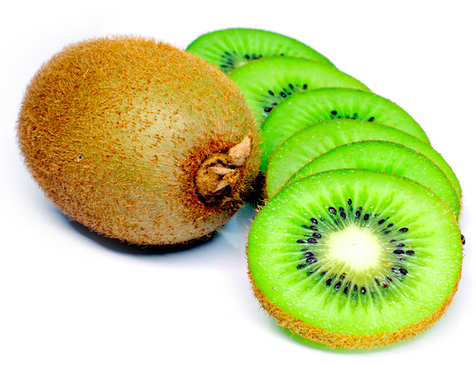

**9. Papaya:**

This popular fruit is most commonly known as one of the best [vitamin C foods](http://www.globalhealingcenter.com/natural-health/foods-high-in-vitamin-c/), but it’s also high in Vitamin E. Just one papaya will give you approximately 17% of your daily needs. Try adding fresh or frozen papaya to fruit smoothies, along with other fruity vitamin E foods on this list for an extra healthy snack!



**10. Green Olives:**

From the oil to the fruit, eating olives is an excellent way of getting your daily needs for vitamin E. Just one cup of olives can give you approximately 20% of your daily recommended amount.

